A public services platform serving multiple cities.
Fabio Augusto De Oliveira Dutra
Gumashtha Devangiri Pandukabhaya Punchi Wedikkarage Don
Jose Vidal Asencio Santos
Mehrthur Luís Lemos da Silva
The University of Niagara Falls Canada
Term 1
Teacher : Dr. William Pourmajidi
October 13, 2026

Introduction
The platform described in the assignment aims to integrate information from public departments across multiple cities to support regional planning, service coordination, and operational decision-making. Its data sources include transportation and environmental sensor readings, geographic locations, citizen service requests, multimedia evidence, maintenance records, emergency response rules, and historical planning information. This diversity requires a database strategy that considers both the characteristics of the data and users’ access requirements.

Figure 1 - Smart City

The main challenge is to support different workloads within a coherent architecture. Managing service requests and work orders requires consistent updates and efficient record retrieval, while sensor monitoring involves frequent data collection and time-based queries.
Geographic searches, image and video storage, and historical analysis introduce additional requirements. The design must therefore evaluate how operational, analytical, and specialized components can work together while accounting for their benefits, costs, and maintenance needs.
This report recommends a database strategy for the Smart Regional Services Platform. It examines platform requirements, database architecture, storage and retrieval approaches, indexing strategies, trade-offs, specialized database models, and contemporary processing paradigms. The final recommendation integrates these choices and identifies implementation priorities to support performance, scalability, and maintainability.

Part 1 – Platform Requirements Analysis
According to Vazquez and Simões (2016), the main purpose of requirements specification is to document customers’ needs accurately and comprehensively and obtain their approval of the proposed product. It also helps the development team understand what customers expect, serving as an important communication tool between customers and developers.

Component | Application to the Platform
Overview | Objective: integrate public service data across multiple cities. Main stakeholders: citizens, municipal teams, emergency response operators, and regional managers.
System Models | System models illustrate the relationships between the platform, citizens, municipal departments, and sensors through a context diagram. The requirements analysis table complements this model by documenting the eight data sources, their data types, expected access patterns, potential performance concerns, and initial database design implications. The architecture diagram is presented in Part 2
Functional Requirements | Register service requests, attach evidence, receive sensor readings, query locations, track maintenance, evaluate emergency rules, and retrieve historical data.
Nonfunctional Requirements | Performance, scalability, availability, security, and data integrity requirements. Numerical targets not provided in the scenario should be identified as assumptions to be validated.
Detailed Requirements Specification | For each function, describe the users, data involved, conditions, rules, and expected outcomes.

The following table identifies the eight data sources, their expected access patterns, possible performance concerns, and initial database design implications.

Data Source / Platform Requirement | Type of Data | Expected Access Pattern | Possible Performance Concern | Initial Database Design Implication
ROAD_​AND_​FACILITY_​LOCATIONS | Spatial points, lines and polygons; structured and variable attributes. | Find nearby facilities, roads intersecting a zone, and locations linked to operational records. | Expensive spatial joins and inconsistent identifiers across stores. | Use PostGIS geometries and spatial indexes; retain stable IDs; justify optional MongoDB attributes against JSONB.
MULTIMEDIA | Images and short videos, with structured metadata and contextual links. | Upload once; retrieve metadata and authorized files for a request, inspection or capture. | Large file volumes, upload failures and costly repeated downloads. | Store files in S3 and metadata in PostgreSQL; track upload state, checksum and stable media IDs.
TRANSPORTATION_​SENSORS | Temporal numerical readings and transit events; device configuration. | Ingest every few seconds; retrieve by sensor, road or intersection, and time range. | Sustained writes, growing history, and slow time-range scans. | Use PostgreSQL operational tables; evaluate time partitioning and sensor/time indexes; keep analytical summaries separate.
ENVIRONMENTAL_​MONITORING | Temporal numerical measurements, observed events and device documents. | Continuous ingestion; retrieve by device, metric and period; examine threshold events and trends. | High ingestion volume, duplicate deliveries and scans across long periods. | Use MongoDB time-series collections for readings; regular collections for devices/events; validate timestamps, units and references.
CITIZEN_​SERVICE_​REQUESTS | Structured requests, descriptions, assignments and temporal status history. | Create reports; find open requests by city, status or department; retrieve one request and its history. | Concurrent status changes, growing queues and inefficient filtered lists. | Use PostgreSQL transactions, constrained status transitions and indexes aligned with city/status/department queries.
FACILITY_​MAINTENANCE | Structured inspections, work orders, teams, costs and equipment usage. | Assign work; list outstanding orders; retrieve facility history and cost totals. | Concurrent updates, multi-table retrieval and expensive historical aggregation. | Use transactional PostgreSQL tables and local FKs; index facility/time and status; move reporting aggregates to analytics.
EMERGENCY_​RULES_​AND_​RESPONSE | Versioned rules, conditions, alerts, actions and escalation history. | Retrieve effective rules; evaluate incoming events; find unacknowledged alerts and their history. | Event bursts, repeated alerts and slow rule or notification processing. | Store rules and alerts in PostgreSQL; evaluate through a service with version tracking, deduplication and delivery retries.
HISTORICAL_​PLANNING | Archived reports, temporal summaries and analytical dimensions and facts. | Compare cities, facilities and reporting periods; examine seasonal trends and planning indicators. | Large aggregations competing with operational activity; inconsistent or delayed source data. | Use a separate PostgreSQL analytical database with validated incremental loads, shared dimensions and daily summaries.

Requirements Analysis
This platform is an advanced database problem because its information has different structures, arrival rates, relationships, and uses. A citizen request requires accountable assignment and consistent status updates, while a sensor stream produces repeated observations that are normally retrieved by device and time. A geographic query depends on spatial relationships rather than an identifier alone. Multimedia retrieval also involves transferring files whose size greatly exceeds their metadata. The design must coordinate these workloads while keeping identifiers, timestamps, and access controls consistent across participating cities.
Transportation and environmental readings are likely to create sustained storage growth because devices report repeatedly. Queries over long periods can scan many observations unless records are organized around their access patterns. Incoming messages may arrive late or be delivered again, so ingestion needs validation and duplicate handling. Multimedia evidence presents a different challenge: file size, upload reliability, and repeated downloads. The proposed separation between object storage and a searchable metadata catalogue addresses these differences. Geographic searches and historical aggregations can also become expensive as coverage and reporting periods expand.
Several sources require specialized database thinking. Road geometries, facility positions, and service-zone boundaries need spatial operations supported by PostGIS. Sensor measurements require temporal organization, appropriate units, and clear treatment of missing observations. Images and videos need an object-storage approach alongside relational metadata. Emergency response depends on versioned conditions and event evaluation; the proposed rule service evaluates those conditions, while PostgreSQL preserves the rules and resulting actions. Flexible environmental documents and optional location attributes may benefit from document storage, although flexibility alone does not justify introducing another database where JSONB would meet the same requirement.
Operational decisions use current, actionable information. Municipal staff need open citizen requests, assigned maintenance work, and reliable status histories. Emergency operators need relevant observations, effective rules, and alerts awaiting acknowledgement. Transportation and environmental monitoring also support immediate assessments of traffic or hazardous conditions. These same records can support analytical decisions after consolidation: managers can compare congestion, seasonal environmental patterns, request resolution, facility expenditure, and infrastructure usage across cities. Consequently, most operational sources serve both purposes, but analytical queries should run against a separate reporting component rather than competing with service delivery.
The requirements table connects each source to the way it will be accessed and the performance risk that follows. Its database implications are initial design decisions, not measured guarantees. The assignment does not provide device counts, event volumes, file sizes, concurrent-user estimates, latency targets, availability targets, or retention periods. These values must be confirmed before capacity and service-level commitments are established. Access permissions must also distinguish citizens, municipal teams, emergency personnel, and regional managers. Shared identifiers and validated references must preserve links between locations, requests, work orders, and evidence. This combination of workload analysis, specialized data handling, and explicit assumptions provides the basis for the architecture recommendation.

Part 2 – Database Architecture Recommendation
The overall architecture separates operational service delivery from historical analysis. Figure 2 shows the proposed components, user groups, and major data flows.
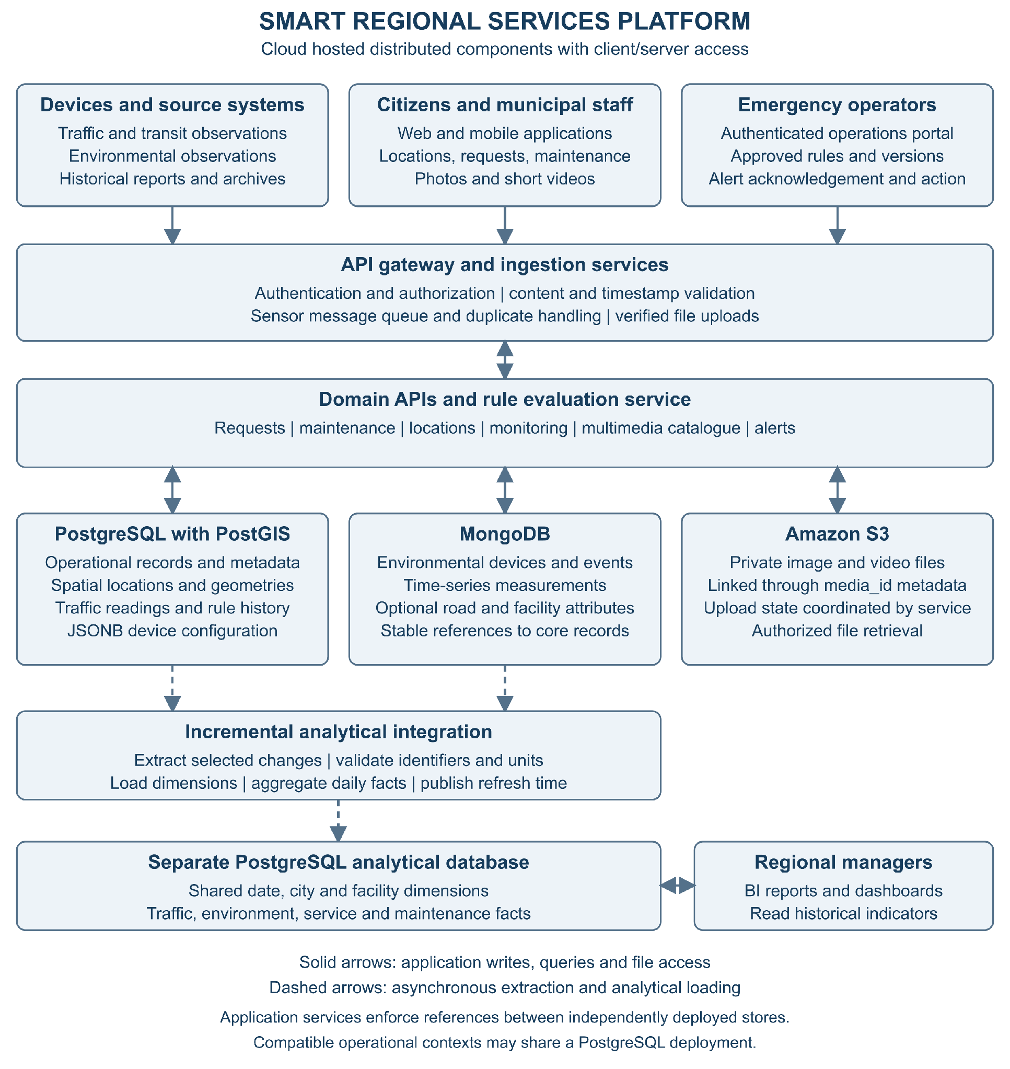
Note. Solid arrows show application access. Dashed arrows show asynchronous analytical integration. Component placement represents responsibilities and does not require one server per context.

Architecture Justification
We recommend a cloud-hosted distributed architecture with client/server access and polyglot persistence. Applications access domain APIs, and the APIs coordinate several storage components according to their workloads. This follows the storage-selection principle discussed by Fowler (2011): different uses of data can justify different persistence approaches. Distribution here refers to cooperating operational, document, object-storage, and analytical components. It does not require a separate database server for every context, and the design does not assume that every participating city needs an independent database deployment.
Citizens use web or mobile applications to submit requests, attach evidence, and follow progress. Municipal staff use authenticated applications to manage locations, triage requests, and coordinate maintenance. Emergency operators review alerts and record response actions, while regional managers use reporting dashboards. An API gateway provides a common entry point for application traffic. Services check authorization and validate submitted content before accepting changes. Device observations enter through an ingestion service and a message queue so that temporary downstream delays can be absorbed. Upload handling verifies file completion before evidence becomes available to other contexts.
PostgreSQL supports operational transactions for requests, departments, maintenance, transportation devices and readings, multimedia metadata, and emergency rule history. PostGIS extends the location component with geometry storage and spatial queries. JSONB stores transportation device configuration where fields differ by sensor type. Related updates, such as a request status and its history, are committed within the owning operational database. A context identifies ownership and responsibility; several compatible contexts may share one PostgreSQL deployment. Conversely, independently deployed stores exchange stable identifiers through application-managed references rather than relying on cross-database foreign keys.
MongoDB supports environmental device documents, observed events, and a proposed time-series collection for measurements. Supplementary road and facility documents remain optional: their value must be demonstrated against the simpler alternative of keeping variable attributes in PostgreSQL JSONB. Amazon S3 stores images and short videos, while PostgreSQL retains their metadata and evidence links. The upload service coordinates these components through pending, available, and failed states. A rule evaluation service consumes relevant observations, retrieves an approved rule version, and records resulting alerts and actions. Notification delivery uses retries and deduplication; database triggers are not assumed to implement the rule engine.
A separate PostgreSQL analytical database supports historical and planning workloads. An incremental integration process extracts selected operational changes, validates identifiers and units, and loads dimensions before daily facts. Reporting queries compare periods, cities, traffic conditions, environmental measurements, service performance, and maintenance costs. Dashboards display the latest successful refresh time because analytical data may lag behind operational activity. Only metadata and selected indicators need to enter this component; large evidence files remain in S3. Keeping analytical processing separate reduces competition between broad reporting scans and operational transactions.
Scalability comes from expanding ingestion workers and application instances independently, buffering event bursts, and evaluating time partitioning and workload-specific indexes where justified. Additional cities use shared identifiers and city-scoped permissions, while new sources enter through documented ingestion contracts. Maintainability depends on clear context ownership, versioned APIs, schema and document validation, monitored integration jobs, and tested backup and restoration procedures. These choices introduce costs: more components require monitoring, and asynchronous integration creates temporary differences between stores. The implementation should therefore begin with shared locations, operational PostgreSQL services, and the multimedia catalogue, then add specialized components where workload evidence supports them. Capacity, retention, recovery, and response-time targets remain assumptions to validate with stakeholders.

Schema / Context | Proposed Technology | Responsibility / Business Justification
ROAD_AND_FACILITY_LOCATIONS | PostgreSQL with PostGIS + MongoDB | PostGIS stores geometries and supports spatial queries; MongoDB stores flexible attributes. Shared identifiers link the records.
MULTIMEDIA | PostgreSQL + Amazon S3 | PostgreSQL stores metadata and record links; S3 stores images and videos.
TRANSPORTATION_SENSORS | PostgreSQL | Store time-stamped readings, events, and sensor attributes, with JSONB for device configuration.
ENVIRONMENTAL_MONITORING | MongoDB | Store time-stamped measurements, events, and device attributes.
CITIZEN_SERVICE_REQUESTS | PostgreSQL | Manage requests, statuses, priorities, and responsible departments.
FACILITY_MAINTENANCE | PostgreSQL | Manage inspections, work orders, teams, costs, and completion status.
EMERGENCY_RULES_AND_RESPONSE | PostgreSQL + Rule Evaluation Service | Store rules, versions, and history; evaluate events and generate alerts.
HISTORICAL_PLANNING | Separate PostgreSQL Analytical Database | Consolidate data for reporting and regional planning.
The order below begins with shared foundations and progresses to the processes that depend on them. Each context has a defined responsibility, workflow, and data ownership. Contexts may share technologies without requiring a separate physical database for each one.

Order | Context | Responsibility | Workflow | Dependencies
1 | ROAD_AND_FACILITY_LOCATIONS | Maintain cities, roads, public buildings, parks, bus stops, and service zones. | Municipal staff create or update a location → the system validates the information → stores geometry and attributes → makes the records available to other services. | Foundational context, independent of the other contexts presented.
2 | MULTIMEDIA | Receive and catalogue images, videos, and, as a proposed extension, audio from different channels. | Source uploads a file → service validates it → stores it in S3 → records metadata → returns an identifier → originating context links the evidence to its record. | A file can exist before being linked to a request, inspection, or capture event.
3 | TRANSPORTATION_SENSORS | Register devices and record speed, road occupancy, congestion, and public transit events. | Sensor sends a reading → ingestion validates the device, timestamp, and content → stores the reading → updates monitoring views → forwards relevant events for rule evaluation. Camera captures are linked to multimedia evidence. | ROAD_AND_FACILITY_LOCATIONS; MULTIMEDIA when images or videos are involved.
4 | ENVIRONMENTAL_MONITORING | Record air quality, temperature, noise, water levels, and environmental events. | Device sends a measurement → ingestion validates it → stores it → updates indicators → forwards relevant conditions for rule evaluation. | ROAD_AND_FACILITY_LOCATIONS; MULTIMEDIA when supporting evidence is available.
5 | CITIZEN_SERVICE_REQUESTS | Register reported problems and support service tracking. | Citizen provides a category, description, and location → optionally attaches evidence → receives a tracking number → staff triage the request → assign responsibility → record progress → resolve and close it. | ROAD_AND_FACILITY_LOCATIONS; MULTIMEDIA for optional attachments. May generate a maintenance demand.
6 | FACILITY_MAINTENANCE | Plan and track inspections, work orders, teams, equipment, and costs. | Inspection, service request, or preventive schedule generates a demand → coordinator creates a work order → assigns priority and team → team performs the work and records activities, costs, and evidence → supervisor verifies and closes the order → originating request is updated, where applicable. | ROAD_AND_FACILITY_LOCATIONS; MULTIMEDIA for evidence; CITIZEN_SERVICE_REQUESTSwhen work originates from a reported issue.
7 | EMERGENCY_RULES_AND_RESPONSE | Define risk conditions and coordinate alerts, priorities, and escalations. | Authorized staff create and approve a rule → service receives an event → evaluates conditions and the affected zone → records an alert and rule version → notifies responsible personnel → tracks acknowledgement, action, escalation, and closure. | ROAD_AND_FACILITY_LOCATIONS and event sources, including TRANSPORTATION_SENSORS, ENVIRONMENTAL_MONITORING, and CITIZEN_SERVICE_REQUESTS.
8 | HISTORICAL_PLANNING | Consolidate information to analyse trends and support regional decisions. | Integration process extracts operational data → validates, standardizes, and aggregates it → loads the analytical database → produces indicators → managers compare periods and locations → plan resources, maintenance, transportation, and events. | Selected data from the other contexts.

Organization of data

Context / Schema | Main Proposed Tables or Collections | Proposed Technology
ROAD_AND_FACILITY_LOCATIONS | Tables: cities, roads, facilities, service_zones. Collections: road_attributes, facility_attributes. | PostgreSQL with PostGIS + MongoDB
MULTIMEDIA | media_assets. Linking tables belong to their respective contexts below. | PostgreSQL for metadata + Amazon S3 for files
TRANSPORTATION_SENSORS | monitoring_units, sensors, traffic_readings, transit_events, capture_events, capture_media | PostgreSQL, with JSONB for device configuration
ENVIRONMENTAL_MONITORING | Collections: monitoring_devices, environmental_readings, environmental_events | MongoDB
CITIZEN_SERVICE_REQUESTS | service_requests, request_status_history, departments, request_media | PostgreSQL
FACILITY_MAINTENANCE | inspections, work_orders, work_order_status_history, teams, work_order_costs, equipment_usage, inspection_media | PostgreSQL
EMERGENCY_RULES_AND_RESPONSE | response_rules, rule_versions, alerts, alert_actions, escalation_history | PostgreSQL + Rule Evaluation Service
HISTORICAL_PLANNING | Proposed analytical tables: fact_traffic_summary, fact_environmental_summary, fact_service_performance, fact_maintenance_cost, dim_date, dim_city, dim_facility | Separate PostgreSQL Analytical Database

Road And Facility Locations

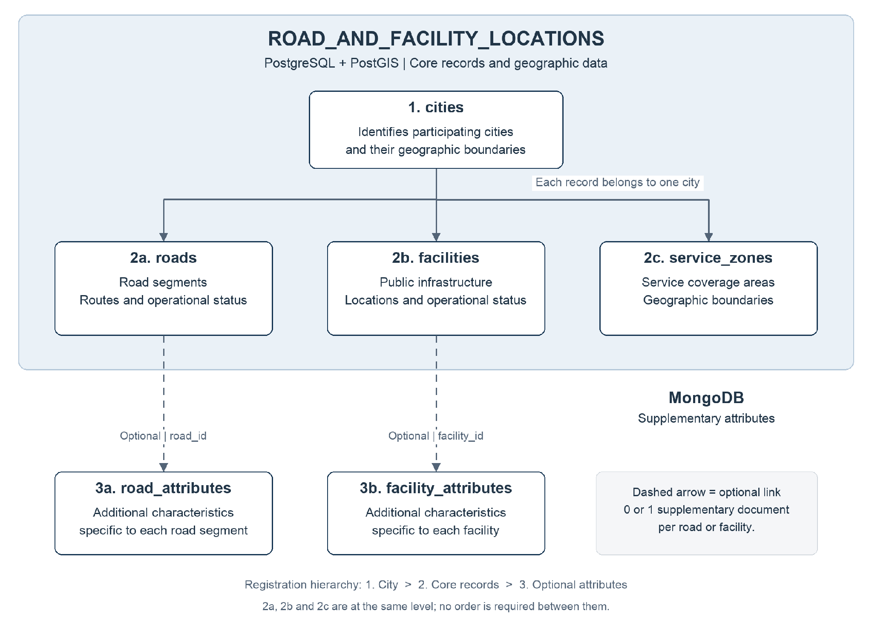
Its responsibility is to maintain the platform’s shared geographic foundation, allowing other contexts to identify cities, roads, public facilities, and service zones.
Arrows represent data associations rather than processing order. PostgreSQL maintains core records and geographic data; MongoDB stores supplementary attributes linked through shared identifiers.
Workflow example: Municipal staff register a park in facilities, linking it to a record in cities. Its geographic location is stored in PostGIS, while supplementary characteristics are stored in facility_attributes using the same identifier. Citizen requests and maintenance records can subsequently reference that park. Each core record belongs to one city in this proposed model. Roads crossing municipal boundaries are divided into segments. Service zones may overlap because different services can use different coverage boundaries. The application coordinates references and updates between PostgreSQL and MongoDB.

Table / Collection | Information Stored | Business Justification
cities | City identifier, name, and geographic boundary. | Organize records by municipality and support comparisons across cities.
roads | Road segment identifier, city, name, category, operational status, and geometry. | Locate transportation readings, road-related requests, and interventions.
facilities | Facility identifier, city, name, category, operational status, and location. | Provide a common reference for service requests, inspections, and maintenance. Facilities include buildings, parks, parking lots, and bus stops.
service_zones | Zone identifier, city, service category, and geographic boundary. | Identify which service areas cover a given location.
road_attributes | Supplementary attributes that vary by road category. | Accommodate specific road characteristics without changing the core relational structure.
facility_attributes | Supplementary attributes that vary by facility category. | Accommodate details such as building capacity, park equipment, or bus stop amenities.

Cities
Each record represents a participating city.
Field | Data Type | Required / Constraint | Purpose
city_id | UUID | Required; Primary Key | Uniquely identify the city.
name | TEXT | Required | Official city name.
boundary | GEOMETRY(MultiPolygon, 4326) | Optional | Represent the municipal boundary, when available.
created_at | TIMESTAMPTZ | Required | Record when the city was registered.
updated_at | TIMESTAMPTZ | Required | Record the latest update time.

Roads
Each record represents a road segment belonging to one city. Roads crossing municipal boundaries are divided into segments.
Field | Data Type | Required / Constraint | Purpose
road_id | UUID | Required; Primary Key | Uniquely identify the road segment.
city_id | UUID | Required; Foreign Key → cities.city_id | Identify the city responsible for the segment.
name | TEXT | Optional | Road name, where available.
road_type | TEXT | Required; controlled values | Classify the segment, for example local, arterial, or highway.
status | TEXT | Required; controlled values | Indicate its operational state, for example open, restricted, or closed.
geometry | GEOMETRY(LineString, 4326) | Required | Represent the geographic path of the segment.
created_at | TIMESTAMPTZ | Required | Record registration time.
updated_at | TIMESTAMPTZ | Required | Record the latest update time.

Facilities
Each record represents a public facility or infrastructure asset.
Field | Data Type | Required / Constraint | Purpose
facility_id | UUID | Required; Primary Key | Uniquely identify the facility.
city_id | UUID | Required; Foreign Key → cities.city_id | Identify the city to which the facility belongs.
name | TEXT | Required | Facility name or descriptive label.
facility_type | TEXT | Required; controlled values | Identify the category: public_building, park, parking_lot, or bus_stop, for example.
status | TEXT | Required; controlled values | Indicate whether the facility is operational, restricted, or closed.
location | GEOMETRY(Point, 4326) | Required | Store a representative location, such as the main entrance.
footprint | GEOMETRY(MultiPolygon, 4326) | Optional | Represent the full geographic area of a building, park, or parking lot.
created_at | TIMESTAMPTZ | Required | Record registration time.
updated_at | TIMESTAMPTZ | Required | Record the latest update time.

Service Zones
Each record represents a geographic coverage area for a service within one city.
Field | Data Type | Required / Constraint | Purpose
zone_id | UUID | Required; Primary Key | Uniquely identify the zone.
city_id | UUID | Required; Foreign Key → cities.city_id | Identify the city to which the zone belongs.
name | TEXT | Required | Human-readable zone name.
service_type | TEXT | Required; controlled values | Identify the service, such as emergency_response, maintenance, or waste_collection.
boundary | GEOMETRY(MultiPolygon, 4326) | Required | Define the coverage area.
is_active | BOOLEAN | Required | Indicate whether the zone is currently in use.
created_at | TIMESTAMPTZ | Required | Record registration time.
updated_at | TIMESTAMPTZ | Required | Record the latest update time.

Road Attributes
Each optional document contains supplementary attributes for one road segment.
Field | Data Type | Required / Constraint | Purpose
_id | String containing a UUID | Required; unique | Match the PostgreSQL road_id.
attributes | Object | Required | Contain the supplementary road characteristics.
attributes.surface_material | String | Optional | Describe the surface, such as asphalt or concrete.
attributes.lane_count | Integer | Optional; greater than zero | Record the number of lanes.
attributes.cycle_lane_present | Boolean | Optional | Indicate whether a cycle lane is present.
attributes.sidewalk_present | Boolean | Optional | Indicate whether a sidewalk is present.
created_at | BSON Date | Required | Record document creation time.
updated_at | BSON Date | Required | Record the latest update time.

Facility Attributes
Each optional document contains supplementary attributes for one facility. Fields depend on its category.
Field | Data Type | Required / Constraint | Purpose
_id | String containing a UUID | Required; unique | Match the PostgreSQL facility_id.
attributes | Object | Required | Contain category-specific facility characteristics.
attributes.building_capacity_persons | Integer | Optional; nonnegative | Record the capacity of a public building.
attributes.accessible_entrance | Boolean | Optional | Indicate whether an accessible entrance is available.
attributes.parking_space_count | Integer | Optional; nonnegative | Record the capacity of a parking facility.
attributes.park_amenities | Array of String | Optional | List amenities such as playground, picnic_area, or sports_court.
attributes.bus_stop_shelter | Boolean | Optional | Indicate whether a bus stop has a shelter.
created_at | BSON Date | Required | Record document creation time.
updated_at | BSON Date | Required | Record the latest update time.

Multimedia
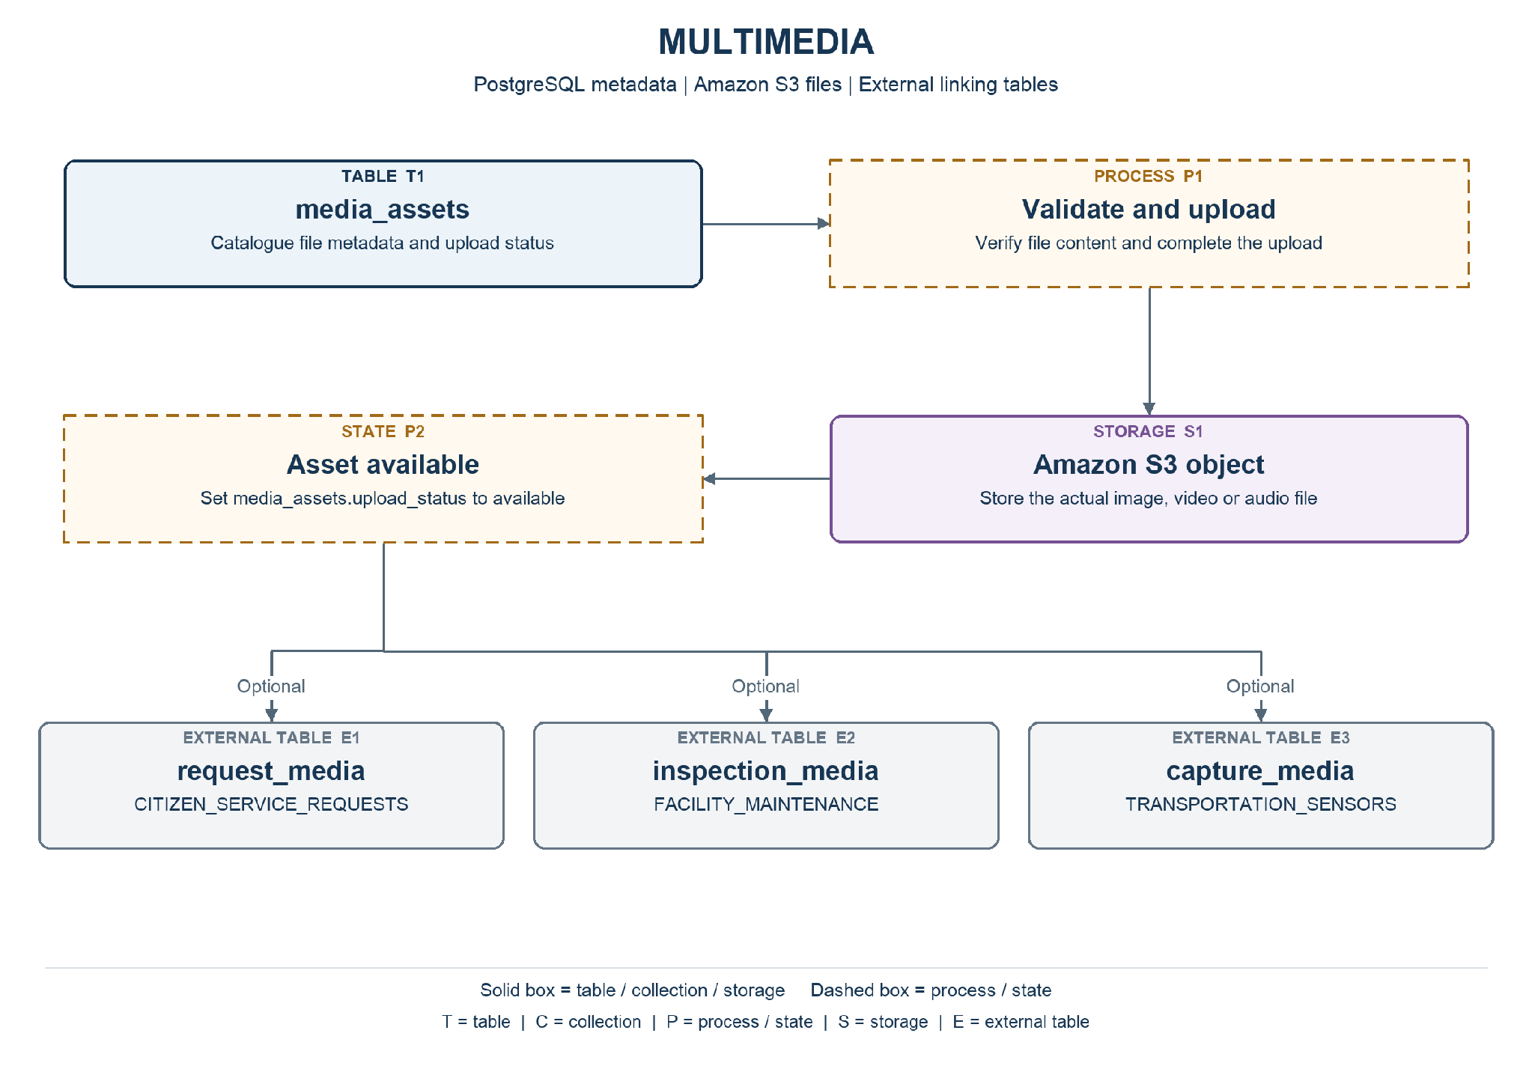
Note. Solid boxes identify tables, collections, or storage. Dashed boxes identify processes or states. External components are labelled. Optional links are marked explicitly.
Responsibility: Receive and catalogue images and videos from citizens, inspectors, and cameras. Audio is an optional extension. The catalogue can exist before an asset is linked to a business record.
Workflow: Upload request → validate format and size → allocate an asset identifier → store the file in S3 → verify completion → mark the asset available → return its identifier to the originating service.

Tables and Collections
Table / Collection | Information Stored | Business Justification
media_assets | Identify each file, its origin, storage location, and availability status. | Make evidence discoverable and traceable across channels without putting large files in operational tables.

Fields and Constraints
PK = primary key; FK = foreign key. An external reference is validated by the application or integration service, rather than a foreign key across independent databases. Field definitions below are the proposed logical design.

Media Assets
Identify each file, its origin, storage location, and availability status.
Field | Data Type | Required / Constraint | Purpose
media_id | UUID | Required; PK | Uniquely identify the asset.
media_type | TEXT | Required; controlled values | image or video; audio only if the extension is enabled.
mime_type | TEXT | Required | Validated content type, such as image/jpeg.
original_filename | TEXT | Required | Preserve the submitted filename for display.
size_bytes | BIGINT | Required; >= 0 | Record the file size in bytes.
source_channel | TEXT | Required; controlled values | citizen_portal, field_inspection, or traffic_camera.
storage_bucket | TEXT | Required | Name the S3 bucket.
storage_key | TEXT | Required; unique with bucket | Identify the object within the bucket.
upload_status | TEXT | Required; controlled values | pending, available, or failed.
checksum_sha256 | TEXT | Optional | Record a verified checksum for integrity checks.
duration_seconds | NUMERIC(12,3) | Optional; >= 0 | Duration of a video or audio asset; absent for images.
captured_at | TIMESTAMPTZ | Optional | Capture time supplied by the source, when known.
received_at | TIMESTAMPTZ | Required | Time the upload was received.

Relationships and Validation
The application coordinates S3 and PostgreSQL because a database transaction cannot atomically commit both. Assets remain pending until the upload is verified; failed uploads are retried or cleaned up. Linking tables belong to their originating contexts. Multiple contexts may reference one asset. Files are private and retrieved through authorized application access.

Transportation Sensors
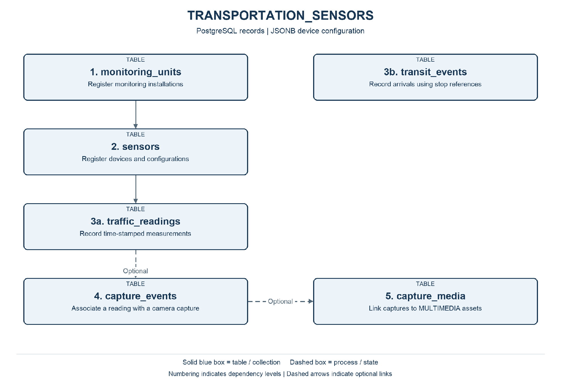
Note. Numbering indicates dependency levels. Solid blue boxes identify tables or collections; dashed boxes identify processes. Dashed arrows indicate optional links.
Responsibility: Maintain monitoring installations and devices, record individual or aggregate traffic measurements, and store transit arrival events. Camera capture is an optional extension to traffic monitoring.
Workflow: Register an installation and its devices → receive and validate readings or transit events → store measurements → present monitoring information → route relevant events to emergency rule evaluation. Optional camera captures link a reading to evidence.

Tables and Collections
Table / Collection | Information Stored | Business Justification
monitoring_units | Group devices installed at the same monitoring point. | Keep device installations tied to a shared physical monitoring point.
sensors | Register radars, cameras, and other transportation devices. | Support equipment configuration, availability tracking, and maintenance.
traffic_readings | Store one measurement from one device at a specified time. | Enable comparisons of traffic conditions by device, place, and time.
transit_events | Record actual arrivals and compare them with schedules. | Measure punctuality and identify recurring transit delays.
capture_events | Associate an optional camera capture with a traffic reading. | Keep optional camera evidence associated with the relevant measurement for review.
capture_media | Associate capture events with multimedia assets. | Retrieve supporting files without duplicating their catalogue records.

Fields and Constraints
PK = primary key; FK = foreign key. An external reference is validated by the application or integration service, rather than a foreign key across independent databases. Field definitions below are the proposed logical design.

Monitoring Units
Group devices installed at the same monitoring point.
Field | Data Type | Required / Constraint | Purpose
unit_id | UUID | Required; PK | Identify the installation.
city_id | UUID | Required; external reference | Reference the responsible city.
road_id | UUID | Optional; external reference | Reference a road segment.
description | TEXT | Required | Describe the monitoring point.
lane_number | INTEGER | Optional; > 0 | Identify the monitored lane, when applicable.
location | GEOMETRY(Point,4326) | Required | Position of the installation; requires PostGIS.
status | TEXT | Required; controlled values | active, inactive, or maintenance.
created_at | TIMESTAMPTZ | Required | Record creation time in UTC.
updated_at | TIMESTAMPTZ | Required | Latest update time in UTC.

Sensors
Register radars, cameras, and other transportation devices.
Field | Data Type | Required / Constraint | Purpose
sensor_id | UUID | Required; PK | Identify the device.
unit_id | UUID | Required; local FK | Reference monitoring_units.unit_id.
sensor_type | TEXT | Required; controlled values | radar, camera, occupancy_detector, or other approved type.
status | TEXT | Required; controlled values | active, inactive, or maintenance.
configuration | JSONB | Required; JSON object | Store device-specific settings validated by sensor type.
configuration.sampling_interval_seconds | JSON integer | Radar; > 0 when present | Configure the interval between readings.
configuration.measured_variables | JSON array of strings | Radar; optional | List measurements, such as speed_kmh.
configuration.capture_mode | JSON string | Camera; optional | triggered or continuous.
configuration.resolution | JSON object | Camera; optional | Group output image dimensions.
configuration.resolution.width_px | JSON integer | Camera; > 0 when present | Image width in pixels.
configuration.resolution.height_px | JSON integer | Camera; > 0 when present | Image height in pixels.
created_at | TIMESTAMPTZ | Required | Record creation time in UTC.
updated_at | TIMESTAMPTZ | Required | Latest update time in UTC.

Traffic Readings
Store one measurement from one device at a specified time.
Field | Data Type | Required / Constraint | Purpose
reading_id | UUID | Required; PK | Identify the reading.
sensor_id | UUID | Required; local FK | Reference the device producing the measurement.
source_event_id | TEXT | Required; unique per sensor | Prevent duplicate ingestion of the same source reading.
recorded_at | TIMESTAMPTZ | Required | Time of measurement.
measurement_type | TEXT | Required; controlled values | speed, occupancy, or congestion_level.
numeric_value | DOUBLE PRECISION | Conditional | Value for speed or occupancy; null for categorical readings.
category_value | TEXT | Conditional | Congestion category; null for numeric readings.
unit | TEXT | Conditional | km/h or percent for numeric readings.
lane_number | INTEGER | Optional; > 0 | Lane measured.
vehicle_track_id | TEXT | Optional | Temporary equipment tracking identifier for individual vehicles.

Transit Events
Record actual arrivals and compare them with schedules.
Field | Data Type | Required / Constraint | Purpose
transit_event_id | UUID | Required; PK | Identify the event.
stop_id | UUID | Required; external reference | Reference a bus stop in facilities.
route_id | TEXT | Required | Transit provider route identifier.
vehicle_id | TEXT | Required | Transit provider vehicle identifier.
source_event_id | TEXT | Required; unique with provider | Identify the source event for duplicate prevention.
provider_id | TEXT | Required | Identify the transit data provider.
scheduled_at | TIMESTAMPTZ | Optional | Expected arrival time, if supplied.
occurred_at | TIMESTAMPTZ | Required | Actual event time.

Capture Events
Associate an optional camera capture with a traffic reading.
Field | Data Type | Required / Constraint | Purpose
capture_id | UUID | Required; PK | Identify the capture.
reading_id | UUID | Required; local FK | Reference the associated traffic reading.
camera_id | UUID | Required; local FK | Reference a sensor classified as a camera.
captured_at | TIMESTAMPTZ | Required | Image capture time.
vehicle_track_id | TEXT | Optional | Correlate the captured vehicle with the reading.
plate_text | TEXT | Optional | Automatically recognized plate text, if this extension is enabled.
plate_confidence | NUMERIC(5,4) | Optional; between 0 and 1 | Confidence of the plate recognition result.
review_status | TEXT | Required; controlled values | pending, accepted, or rejected.

Capture Media
Associate capture events with multimedia assets.
Field | Data Type | Required / Constraint | Purpose
capture_id | UUID | Required; composite PK; local FK | Reference the owning record.
media_id | UUID | Required; composite PK; external reference | Identify an asset in MULTIMEDIA.media_assets.
evidence_role | TEXT | Required | Describe the evidence role, such as before, after, or supporting.

Relationships and Validation
A sensor belongs to one monitoring unit. A unit references a city and optionally a road segment in the location context. JSONB configuration differs by device type. For radar it may contain sampling_interval_seconds (integer) and measured_variables (array of strings); for cameras, capture_mode (string) and resolution (object with integer width_px and height_px). Individual speed and aggregate occupancy are distinct measurement types. Camera-to-vehicle correlation requires validated timing, lane, and tracking information; an automatic plate result is not a confirmed violation. Local FKs enforce relationships only within this PostgreSQL context.

Environmental Monitoring
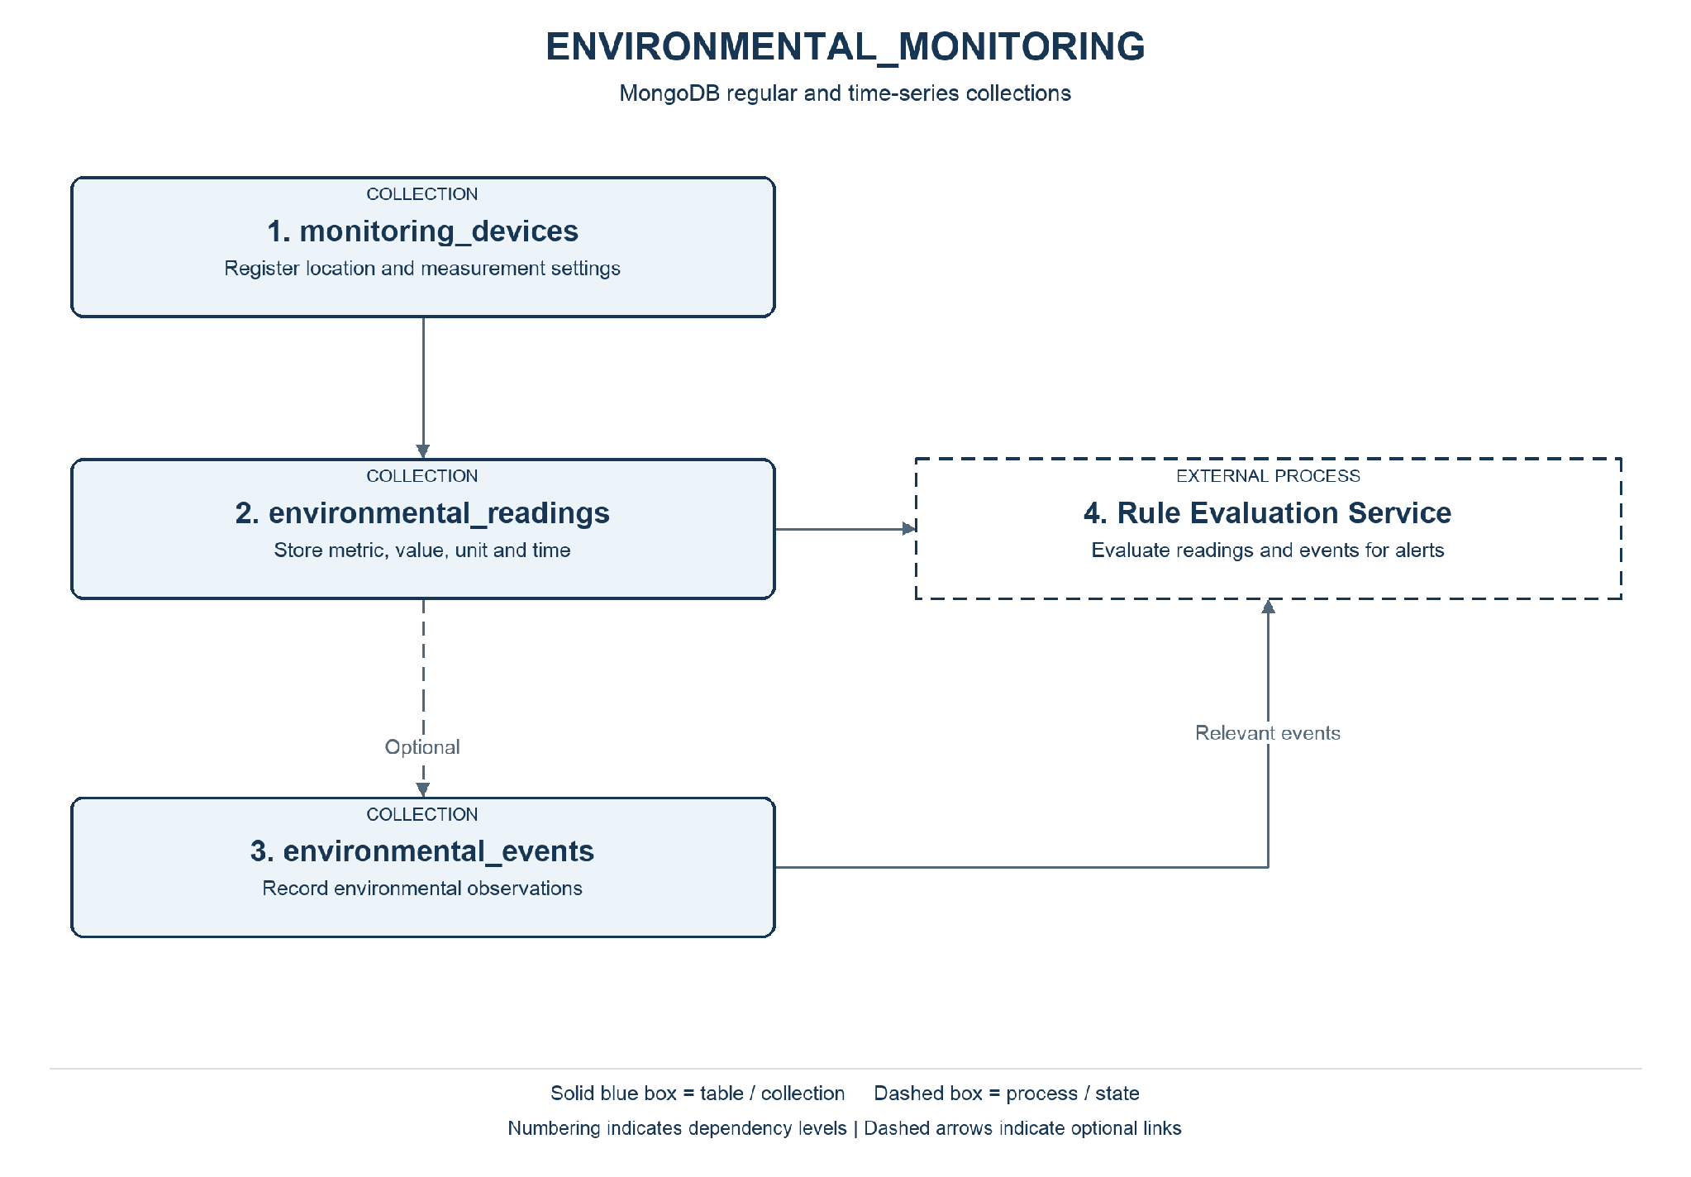
Note. Numbering indicates dependency levels. Solid blue boxes identify tables or collections; dashed boxes identify processes. Dashed arrows indicate optional links.
Responsibility: Maintain device configurations and record environmental measurements and observed events, supporting monitoring and emergency rule evaluation.
Workflow: Register a device → receive a measurement → validate device, metric, unit, and timestamp → store the reading → update monitoring views → forward relevant observations for emergency rule evaluation.

Tables and Collections
Table / Collection | Information Stored | Business Justification
monitoring_devices | Register devices and their measurement capabilities. | Manage heterogeneous environmental devices and their capabilities.
environmental_readings | Store one environmental metric measured at one time. | Support trends and risk detection using traceable measurements.
environmental_events | Record environmental observations and source events. | Give operators contextual observations for investigation and response.

Fields and Constraints
PK = primary key; FK = foreign key. An external reference is validated by the application or integration service, rather than a foreign key across independent databases. Field definitions below are the proposed logical design.

Monitoring Devices
Register devices and their measurement capabilities.
Field | Data Type | Required / Constraint | Purpose
_id | String | Required; unique | Application-assigned device identifier.
city_id | String (UUID) | Required; external reference | Reference the city.
facility_id | String (UUID) | Optional; external reference | Reference the installation hosting the device.
location | Object | Required | GeoJSON point representing device position.
location.type | String | Required; value Point | Identify the GeoJSON geometry type.
location.coordinates | Array<Double> | Required; two values | Longitude followed by latitude.
status | String | Required; controlled values | active, inactive, or maintenance.
configuration | Object | Required | Device settings.
configuration.sampling_interval_seconds | Integer | Required; > 0 | Expected measurement interval.
configuration.metrics | Array<Object> | Required | Supported measurements, each with metric (string) and unit (string).
updated_at | BSON Date | Required | Latest device update time.

Environmental Readings
Store one environmental metric measured at one time.
Field | Data Type | Required / Constraint | Purpose
reading_id | String | Required; application identifier | Identify the reading for traceability.
recorded_at | BSON Date | Required; time field | Time the measurement was taken.
metadata | Object | Required; metadata field | Identify the measurement series.
metadata.device_id | String | Required; logical reference | Reference monitoring_devices._id.
metadata.city_id | String (UUID) | Required; external reference | Identify the responsible city.
metadata.metric | String | Required; controlled values | temperature, water_level, noise_level, or a specific air pollutant.
metadata.unit | String | Required | Unit appropriate to the metric, such as degC or dB.
value | Double | Required | Measured numeric value.
quality_status | String | Required; controlled values | valid, suspect, or invalid.
received_at | BSON Date | Required | Time the platform received the reading.

Environmental Events
Record environmental observations and source events.
Field | Data Type | Required / Constraint | Purpose
_id | String | Required; unique | Identify the event.
device_id | String | Optional; logical reference | Reference the reporting device when applicable.
reading_id | String | Optional; logical reference | Reference a supporting measurement.
city_id | String (UUID) | Required; external reference | Identify the affected city.
event_type | String | Required | Classify the event, such as weather_event or elevated_water_level.
occurred_at | BSON Date | Required | Time of the observed event.
details | Object | Required | Store event-specific attributes; validate by event type.

Relationships and Validation
Monitoring_devices and environmental_events are regular collections. environmental_readings is a proposed time-series collection using recorded_at as its time field and metadata as its metadata field. The application generates reading_id for traceability; ingestion duplicate handling is an application responsibility. UUIDs from PostgreSQL are represented consistently as strings. Environmental events represent observations; response alerts are owned by EMERGENCY_RULES_AND_RESPONSE. Missing measurements are not interpreted as zero.

Citizen Service Requests
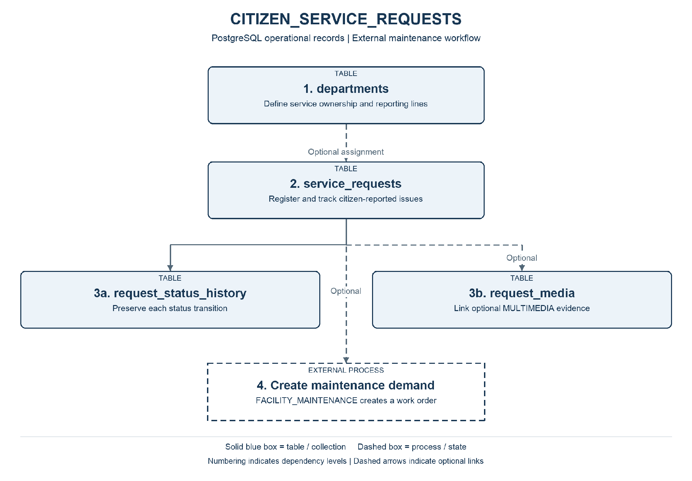
Note. Solid boxes identify tables, collections, or storage. Dashed boxes identify processes or states. External components are labelled. Optional links are marked explicitly.
Responsibility: Register citizen-reported issues, assign departmental ownership, preserve status changes, and link optional supporting evidence.
Workflow: Citizen submits issue details and location → system validates and issues a tracking number → staff triage and assign a department → staff update progress → maintenance is requested where necessary → resolution is recorded and the request is closed.

Tables and Collections
Table / Collection | Information Stored | Business Justification
departments | Identify departments responsible for service delivery. | Establish clear ownership and support departmental reporting structures.
service_requests | Store each citizen-reported issue and its current state. | Provide reliable citizen issue tracking and accountable assignment.
request_status_history | Preserve the progression of a request. | Explain progress, delays, and resolution through an auditable history.
request_media | Link requests to optional supporting files. | Make citizen evidence available to the team handling the request.

Fields and Constraints
PK = primary key; FK = foreign key. An external reference is validated by the application or integration service, rather than a foreign key across independent databases. Field definitions below are the proposed logical design.

Departments
Identify departments responsible for service delivery.
Field | Data Type | Required / Constraint | Purpose
department_id | UUID | Required; PK | Identify the department.
city_id | UUID | Required; external reference | Reference the responsible city.
parent_department_id | UUID | Optional; self FK | Represent a parent department where a hierarchy exists.
name | TEXT | Required | Department name.
is_active | BOOLEAN | Required | Whether the department accepts assignments.

Service Requests
Store each citizen-reported issue and its current state.
Field | Data Type | Required / Constraint | Purpose
request_id | UUID | Required; PK | Identify the request.
tracking_number | TEXT | Required; unique | Provide a public tracking reference.
submitted_by_ref | TEXT | Optional | Opaque identity reference; anonymous reports may omit it.
city_id | UUID | Required; external reference | Reference the city.
road_id | UUID | Optional; external reference | Reference an affected road segment.
facility_id | UUID | Optional; external reference | Reference an affected facility.
department_id | UUID | Optional; local FK | Reference the assigned department after triage.
category | TEXT | Required; controlled values | Classify the issue, such as pothole or broken_streetlight.
description | TEXT | Required | Describe the reported problem.
location | GEOMETRY(Point,4326) | Required | Position of the issue; requires PostGIS.
priority | TEXT | Required; controlled values | low, normal, high, or urgent.
status | TEXT | Required; controlled values | submitted, triaged, assigned, in_progress, resolved, or closed.
resolved_at | TIMESTAMPTZ | Optional | Time resolution was recorded.
created_at | TIMESTAMPTZ | Required | Record creation time in UTC.
updated_at | TIMESTAMPTZ | Required | Latest update time in UTC.

Request Status History
Preserve the progression of a request.
Field | Data Type | Required / Constraint | Purpose
history_id | UUID | Required; PK | Identify the transition.
request_id | UUID | Required; local FK | Reference service_requests.request_id.
from_status | TEXT | Optional | Previous status; absent for initial registration.
to_status | TEXT | Required | New status.
changed_by_ref | TEXT | Required | Identity or service performing the transition.
changed_at | TIMESTAMPTZ | Required | Time of the transition.
note | TEXT | Optional | Explain the action or resolution.

Request Media
Link requests to optional supporting files.
Field | Data Type | Required / Constraint | Purpose
request_id | UUID | Required; composite PK; local FK | Reference the owning record.
media_id | UUID | Required; composite PK; external reference | Identify an asset in MULTIMEDIA.media_assets.
evidence_role | TEXT | Required | Describe the evidence role, such as before, after, or supporting.

Relationships and Validation
City, road, and facility identifiers reference the location context. A request may identify a precise location without referring to an existing facility. Submitter references are opaque identifiers managed by an identity service; personal contact information is outside this dictionary. Current status and its history are updated in one local transaction. A request can lead to several work orders, each referencing the originating request. Status transitions and priority values are validated by application rules.

Facility Maintenance
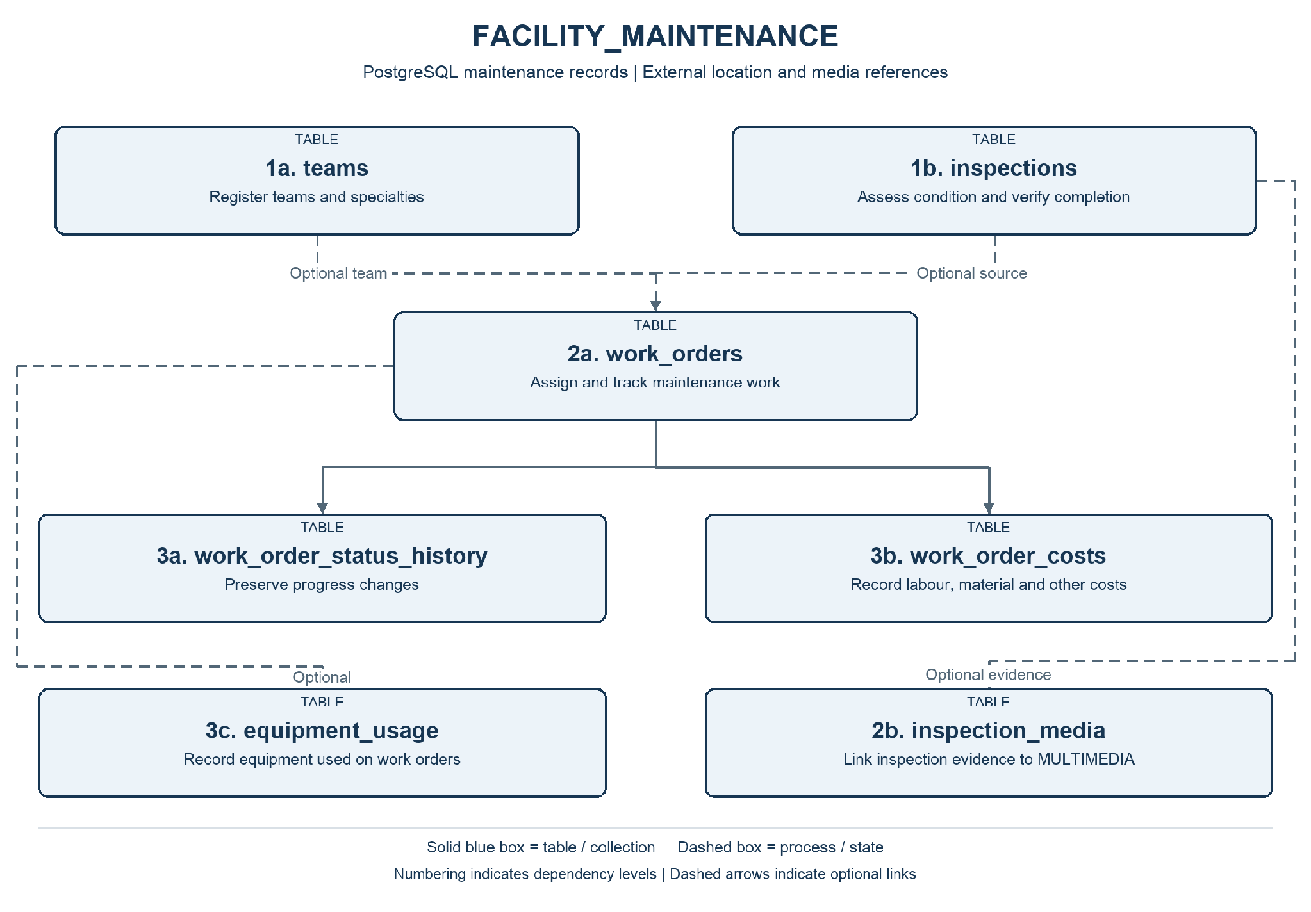
Note. Numbering indicates dependency levels. Solid blue boxes identify tables or collections; dashed boxes identify processes. Dashed arrows indicate optional links.
Responsibility: Coordinate inspections and preventive or corrective maintenance, tracking team assignments, work progress, costs, equipment, and inspection evidence.
Workflow: Inspection, citizen request, or preventive schedule creates a demand → coordinator opens a work order → assigns a team and priority → team records work, equipment use, and costs → supervisor verifies completion → work order closes and the originating request is notified where applicable.

Tables and Collections
Table / Collection | Information Stored | Business Justification
teams | Identify maintenance teams and their specialties. | Support assignment of work to an appropriate maintenance specialty.
inspections | Record an inspection of a public facility. | Document facility condition and support verification of completed repairs.
work_orders | Plan and track maintenance execution. | Coordinate execution, priority, scheduling, and completion of maintenance.
work_order_status_history | Preserve work order status transitions. | Preserve the progression and responsibility for maintenance actions.
work_order_costs | Record individual cost items for a work order. | Support expenditure oversight and comparable cost reporting.
equipment_usage | Record equipment used during maintenance. | Provide accountability for equipment deployed during maintenance.
inspection_media | Link inspection findings to multimedia evidence. | Support assessment and verification with photographic or video evidence.

Fields and Constraints
PK = primary key; FK = foreign key. An external reference is validated by the application or integration service, rather than a foreign key across independent databases. Field definitions below are the proposed logical design.

Teams
Identify maintenance teams and their specialties.
Field | Data Type | Required / Constraint | Purpose
team_id | UUID | Required; PK | Identify the team.
department_id | UUID | Required; external reference | Reference the responsible department.
name | TEXT | Required | Team name.
specialty | TEXT | Required | Primary maintenance specialty.
is_active | BOOLEAN | Required | Whether the team is available for assignment.

Inspections
Record an inspection of a public facility.
Field | Data Type | Required / Constraint | Purpose
inspection_id | UUID | Required; PK | Identify the inspection.
facility_id | UUID | Required; external reference | Reference the inspected facility.
inspector_ref | TEXT | Required | Identity reference of the inspector.
inspected_at | TIMESTAMPTZ | Required | Time of inspection.
inspection_type | TEXT | Required; controlled values | routine, issue_assessment, or completion_verification.
outcome | TEXT | Required; controlled values | satisfactory, action_required, or follow_up.
findings | TEXT | Required | Describe observations and required action.

Work Orders
Plan and track maintenance execution.
Field | Data Type | Required / Constraint | Purpose
work_order_id | UUID | Required; PK | Identify the work order.
facility_id | UUID | Required; external reference | Reference the maintained facility.
source_request_id | UUID | Optional; external reference | Reference an originating citizen request.
source_inspection_id | UUID | Optional; local FK | Reference an inspection that identified the issue.
completion_inspection_id | UUID | Optional; local FK | Reference a completion verification inspection.
team_id | UUID | Optional; local FK | Reference the assigned team.
description | TEXT | Required | Describe the work to perform.
maintenance_type | TEXT | Required; controlled values | preventive or corrective.
priority | TEXT | Required; controlled values | low, normal, high, or urgent.
status | TEXT | Required; controlled values | open, assigned, in_progress, awaiting_verification, completed, or cancelled.
scheduled_for | TIMESTAMPTZ | Optional | Planned start time.
completed_at | TIMESTAMPTZ | Optional | Verified completion time.
created_at | TIMESTAMPTZ | Required | Record creation time in UTC.
updated_at | TIMESTAMPTZ | Required | Latest update time in UTC.

Work Order Status History
Preserve work order status transitions.
Field | Data Type | Required / Constraint | Purpose
history_id | UUID | Required; PK | Identify the transition.
work_order_id | UUID | Required; local FK | Reference the work order.
from_status | TEXT | Optional | Previous status.
to_status | TEXT | Required | New status.
changed_by_ref | TEXT | Required | Identity or service performing the change.
changed_at | TIMESTAMPTZ | Required | Transition time.
note | TEXT | Optional | Explain the action.

Work Order Costs
Record individual cost items for a work order.
Field | Data Type | Required / Constraint | Purpose
cost_id | UUID | Required; PK | Identify the cost item.
work_order_id | UUID | Required; local FK | Reference the work order.
cost_category | TEXT | Required; controlled values | labour, materials, equipment, or external_service.
description | TEXT | Required | Describe the cost item.
amount | NUMERIC(14,2) | Required; >= 0 | Actual cost amount.
currency_code | CHAR(3) | Required | Currency of the cost, such as CAD.
recorded_at | TIMESTAMPTZ | Required | Cost recording time.

Equipment Usage
Record equipment used during maintenance.
Field | Data Type | Required / Constraint | Purpose
usage_id | UUID | Required; PK | Identify the usage record.
work_order_id | UUID | Required; local FK | Reference the work order.
equipment_ref | TEXT | Required | Reference equipment in the municipal asset register.
started_at | TIMESTAMPTZ | Required | Start of equipment use.
ended_at | TIMESTAMPTZ | Optional; >= started_at | End of use, when known.
note | TEXT | Optional | Describe how the equipment was used.

Inspection Media
Link inspection findings to multimedia evidence.
Field | Data Type | Required / Constraint | Purpose
inspection_id | UUID | Required; composite PK; local FK | Reference the owning record.
media_id | UUID | Required; composite PK; external reference | Identify an asset in MULTIMEDIA.media_assets.
evidence_role | TEXT | Required | Describe the evidence role, such as before, after, or supporting.

Relationships and Validation
Facility references are owned by ROAD_AND_FACILITY_LOCATIONS and department references by CITIZEN_SERVICE_REQUESTS. inspections may create work orders; work orders may instead originate from a request or preventive activity. No source inspection or request is mandatory for preventive work. inspection_media links before or after inspection evidence. Completion is verified by an inspection linked through completion_inspection_id. Teams and work orders are locally related. Monetary values are stored with a currency code and are not aggregated across currencies without an explicit conversion policy.

Emergency Rules and Response
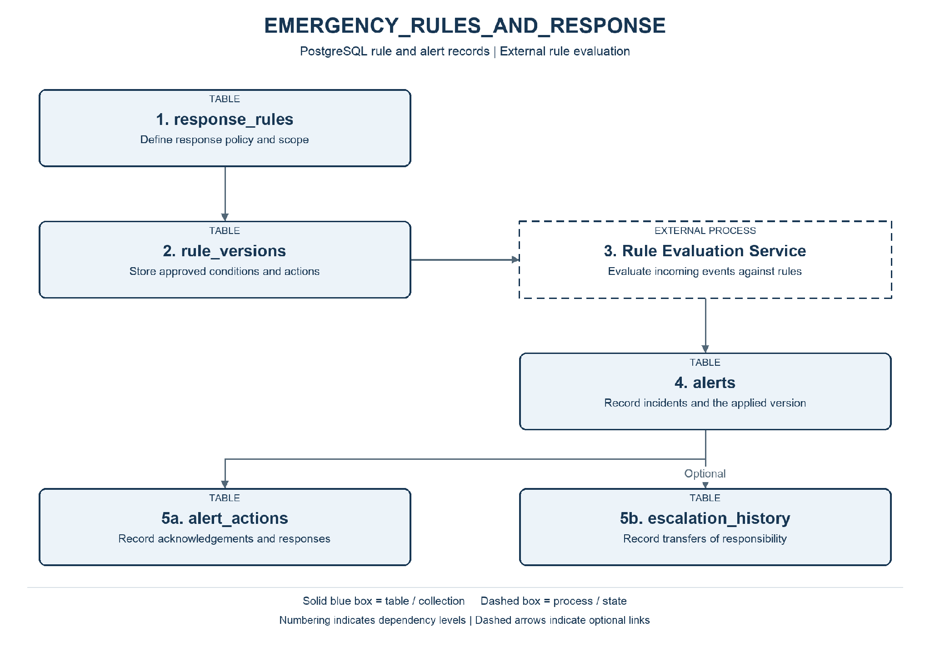
Note. Numbering indicates dependency levels. Solid blue boxes identify tables or collections; dashed boxes identify processes. Dashed arrows indicate optional links.
Responsibility: Maintain approved response rules, evaluate incoming events, and preserve alerts, response actions, and escalation history.
Workflow: Create a rule → approve an immutable version → receive an event → evaluate conditions against the applicable version → record an alert → acknowledge and act → escalate when required → close the alert.

Tables and Collections
Table / Collection | Information Stored | Business Justification
response_rules | Identify response policies and their scope. | Provide governed, clearly scoped response policies.
rule_versions | Preserve approved conditions and response settings. | Make decisions reproducible using the approved conditions applied at the time.
alerts | Record each condition requiring a response. | Keep incidents requiring action visible and prevent duplicate response records.
alert_actions | Track acknowledgements and response activities. | Record acknowledgement and follow-through by responsible personnel.
escalation_history | Track transfers to additional response authorities. | Show why and when responsibility was escalated.

Fields and Constraints
PK = primary key; FK = foreign key. An external reference is validated by the application or integration service, rather than a foreign key across independent databases. Field definitions below are the proposed logical design.

Response Rules
Identify response policies and their scope.
Field | Data Type | Required / Constraint | Purpose
rule_id | UUID | Required; PK | Identify the policy.
name | TEXT | Required | Rule name.
description | TEXT | Required | Business purpose of the rule.
source_context | TEXT | Required; controlled values | Context whose events the rule evaluates.
city_id | UUID | Optional; external reference | Limit the rule to a city; absent for regional scope.
zone_id | UUID | Optional; external reference | Limit the rule to a service zone.
is_active | BOOLEAN | Required | Whether the policy is enabled.
created_at | TIMESTAMPTZ | Required | Record creation time in UTC.
updated_at | TIMESTAMPTZ | Required | Latest update time in UTC.

Rule Versions
Preserve approved conditions and response settings.
Field | Data Type | Required / Constraint | Purpose
rule_version_id | UUID | Required; PK | Identify the version.
rule_id | UUID | Required; local FK | Reference response_rules.rule_id.
version_number | INTEGER | Required; unique per rule | Sequence of versions.
conditions | JSONB | Required; validated object | metric (string), operator (string), threshold (number), unit (string), and optional window_seconds (integer).
priority | TEXT | Required; controlled values | Priority assigned when the condition is met.
target_department_ref | TEXT | Required | Identify the initial responding department.
escalation_after_seconds | INTEGER | Optional; > 0 | Delay before escalation if unresolved.
approval_status | TEXT | Required; controlled values | draft, approved, or retired.
approved_by_ref | TEXT | Conditional | Approver identity; required for approved versions.
effective_from | TIMESTAMPTZ | Required | Start of version applicability.
effective_to | TIMESTAMPTZ | Optional; > effective_from | End of version applicability.

Alerts
Record each condition requiring a response.
Field | Data Type | Required / Constraint | Purpose
alert_id | UUID | Required; PK | Identify the alert.
rule_version_id | UUID | Required; local FK | Reference the exact rule version evaluated.
source_context | TEXT | Required | Identify the originating context.
source_event_id | TEXT | Required | Identifier of the event or reading evaluated.
deduplication_key | TEXT | Required; unique | Prevent duplicate alerts for the same evaluation.
priority | TEXT | Required | Priority captured at alert creation.
status | TEXT | Required; controlled values | open, acknowledged, in_progress, or closed.
triggered_at | TIMESTAMPTZ | Required | Time the alert was generated.
closed_at | TIMESTAMPTZ | Optional | Time response was closed.

Alert_actions
Track acknowledgements and response activities.
Field | Data Type | Required / Constraint | Purpose
action_id | UUID | Required; PK | Identify the action.
alert_id | UUID | Required; local FK | Reference alerts.alert_id.
action_type | TEXT | Required | acknowledged, team_dispatched, status_changed, or closed.
performed_by_ref | TEXT | Required | Identity or service performing the action.
performed_at | TIMESTAMPTZ | Required | Time of action.
note | TEXT | Optional | Describe the action or outcome.

Escalation History
Track transfers to additional response authorities.
Field | Data Type | Required / Constraint | Purpose
escalation_id | UUID | Required; PK | Identify the escalation.
alert_id | UUID | Required; local FK | Reference the alert.
from_department_ref | TEXT | Required | Previous responsible department.
to_department_ref | TEXT | Required | Department receiving the escalation.
reason | TEXT | Required | Explain why escalation occurred.
escalated_at | TIMESTAMPTZ | Required | Time of escalation.

Relationships and Validation
The response_rules identifies a policy; rule_versions stores immutable versions. conditions is a JSONB object validated against an approved rule language, not executable SQL supplied by users. The external service performs evaluation; this design does not claim that PostgreSQL triggers execute the rule engine. Each alert records the exact version applied and the source context plus event identifier. Recording an alert and its initial action should be coordinated locally; notification delivery uses retry and deduplication. Only approved, effective versions can be evaluated.

Historical Planning
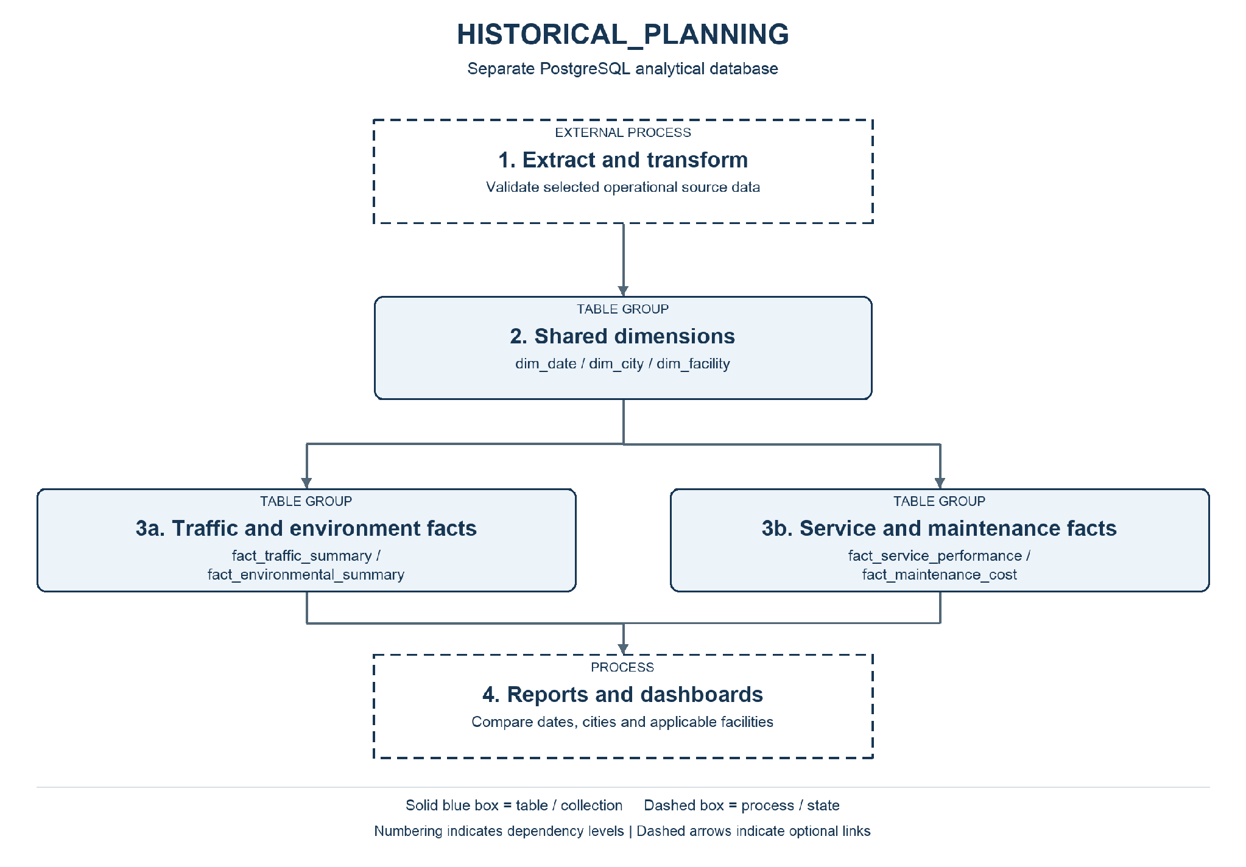
Note. Numbering indicates dependency levels. Solid blue boxes identify tables or collections; dashed boxes identify processes. Dashed arrows indicate optional links.
Responsibility: Consolidate operational information into daily indicators for regional planning without placing reporting workloads on operational stores.
Workflow: Extract changes from operational sources → validate identifiers, dates, units, and completeness → load dimensions → aggregate and upsert daily facts → publish reports with a visible refresh time.

Tables and Collections
Table / Collection | Information Stored | Business Justification
dim_date | Provide a shared reporting calendar. | Make reporting periods consistent across operational domains.
dim_city | Provide a common city dimension. | Enable consistent comparisons between participating cities.
dim_facility | Provide facility context for maintenance indicators. | Connect facility characteristics to maintenance expenditure.
fact_traffic_summary | Grain: one city, road segment, and reporting date. | Support road-level trend comparisons for transportation planning.
fact_environmental_summary | Grain: one city, metric, unit, and reporting date. | Support environmental comparisons using explicit metrics and units.
fact_service_performance | Grain: one city, request category, and reporting date. | Assess service demand and resolution performance by city and category.
fact_maintenance_cost | Grain: one facility, currency, and cost-recording date. | Support maintenance budgets and facility investment decisions.

Fields and Constraints
PK = primary key; FK = foreign key. An external reference is validated by the application or integration service, rather than a foreign key across independent databases. Field definitions below are the proposed logical design.

Dim Date
Provide a shared reporting calendar.
Field | Data Type | Required / Constraint | Purpose
date_key | INTEGER | Required; PK | Calendar key in YYYYMMDD form.
calendar_date | DATE | Required; unique | Actual reporting date.
year_number | SMALLINT | Required | Calendar year.
month_number | SMALLINT | Required; 1 to 12 | Calendar month.
day_of_week | SMALLINT | Required; 1 to 7 | ISO weekday number.

Dim City
Provide a common city dimension.
Field | Data Type | Required / Constraint | Purpose
city_key | BIGINT | Required; surrogate PK | Identify the analytical city record.
source_city_id | UUID | Required; unique | Original city identifier.
city_name | TEXT | Required | City name used for reporting.

Dim Facility
Provide facility context for maintenance indicators.
Field | Data Type | Required / Constraint | Purpose
facility_key | BIGINT | Required; surrogate PK | Identify the analytical facility record.
source_facility_id | UUID | Required; unique | Original facility identifier.
city_key | BIGINT | Required; local FK | Reference dim_city.city_key.
facility_name | TEXT | Required | Facility display name.
facility_type | TEXT | Required | Facility category.

Fact Traffic Summary
Grain: one city, road segment, and reporting date.
Field | Data Type | Required / Constraint | Purpose
traffic_summary_id | BIGINT | Required; surrogate PK | Identify the daily summary.
date_key | INTEGER | Required; local FK | Reference dim_date.date_key.
city_key | BIGINT | Required; local FK | Reference dim_city.city_key.
source_road_id | UUID | Required; grain key | Original road segment identifier.
speed_sample_count | BIGINT | Required; >= 0 | Number of valid speed samples.
average_speed_kmh | DOUBLE PRECISION | Optional | Average of comparable valid speed readings.
average_occupancy_percentage | DOUBLE PRECISION | Optional; 0 to 100 | Average valid occupancy over the reporting period.
loaded_at | TIMESTAMPTZ | Required | Latest successful load time.

Fact Environmental Summary
Grain: one city, metric, unit, and reporting date.
Field | Data Type | Required / Constraint | Purpose
environmental_summary_id | BIGINT | Required; surrogate PK | Identify the daily summary.
date_key | INTEGER | Required; local FK | Reference dim_date.date_key.
city_key | BIGINT | Required; local FK | Reference dim_city.city_key.
metric | TEXT | Required; grain key | Specific environmental variable.
unit | TEXT | Required; grain key | Measurement unit; incompatible units are not combined.
sample_count | BIGINT | Required; >= 0 | Number of valid samples.
minimum_value | DOUBLE PRECISION | Optional | Minimum valid observed value.
maximum_value | DOUBLE PRECISION | Optional | Maximum valid observed value.
average_value | DOUBLE PRECISION | Optional | Average of comparable samples; not an area-weighted city estimate.
loaded_at | TIMESTAMPTZ | Required | Latest successful load time.

Fact Service Performance
Grain: one city, request category, and reporting date.
Field | Data Type | Required / Constraint | Purpose
service_summary_id | BIGINT | Required; surrogate PK | Identify the daily summary.
date_key | INTEGER | Required; local FK | Reference dim_date.date_key.
city_key | BIGINT | Required; local FK | Reference dim_city.city_key.
request_category | TEXT | Required; grain key | Service request category.
submitted_count | BIGINT | Required; >= 0 | Requests submitted on this date.
resolved_count | BIGINT | Required; >= 0 | Requests resolved on this date.
total_resolution_seconds | NUMERIC(20,0) | Required; >= 0 | Sum of creation-to-resolution durations for requests resolved on this date.
loaded_at | TIMESTAMPTZ | Required | Latest successful load time.

Fact Maintenance Cost
Grain: one facility, currency, and cost-recording date.
Field | Data Type | Required / Constraint | Purpose
maintenance_summary_id | BIGINT | Required; surrogate PK | Identify the daily summary.
date_key | INTEGER | Required; local FK | Reference dim_date.date_key.
facility_key | BIGINT | Required; local FK | Reference dim_facility.facility_key.
currency_code | CHAR(3) | Required; grain key | Currency used for the cost total.
cost_item_count | BIGINT | Required; >= 0 | Number of cost entries recorded on this date.
total_cost | NUMERIC(18,2) | Required; >= 0 | Sum of cost entries in the specified currency.
loaded_at | TIMESTAMPTZ | Required | Latest successful load time.

Relationships and Validation
Daily fact tables use a unique constraint on their declared grain. Integration maps source identifiers to analytical keys and loads dimensions before facts. There are no cross-database foreign keys. Group dates in one documented reporting timezone and display the latest successful refresh time. Preserve missing measurements as unknown. Facts join to their applicable dimensions, not to other fact tables.

Entity Relationships

ROAD_AND_FACILITY_LOCATIONS
PK = primary key FK = foreign key (solid line) REF = logical reference (dashed) ID = document identifier
Arrow: parent to child. Label: parent count : child count. 1 = one; 0..1 = optional one; 0..N = zero or many.
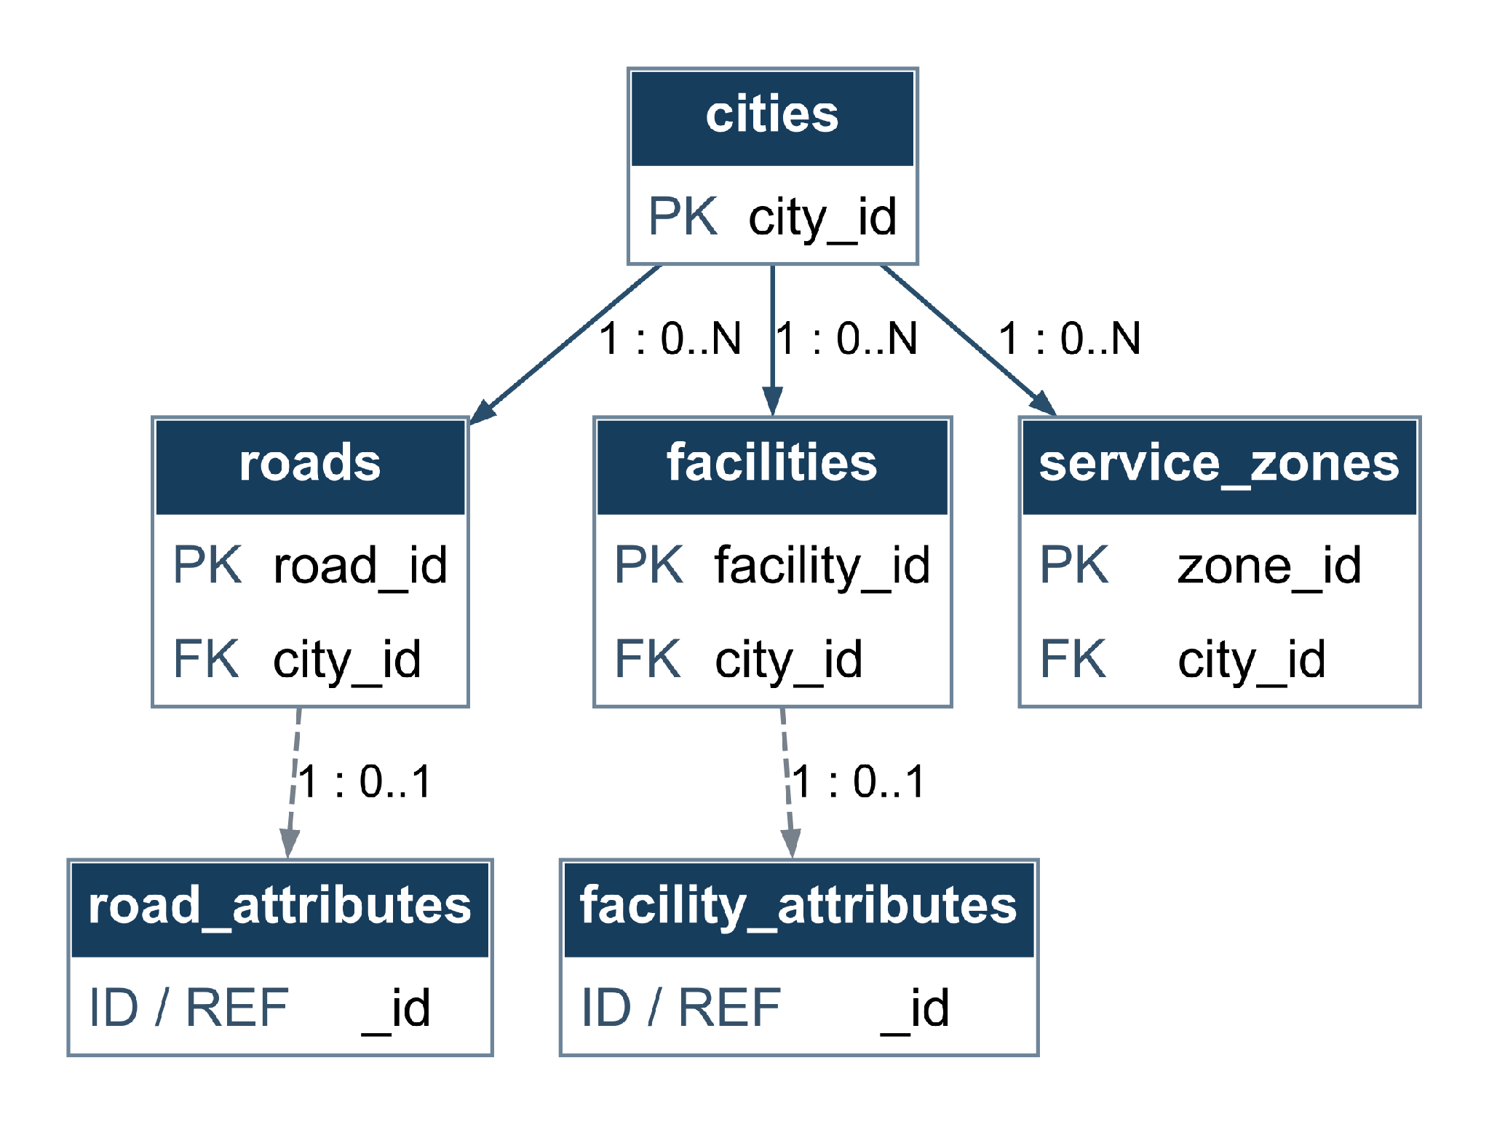
Shared identifiers link each optional MongoDB attribute document to exactly one road or facility. Each parent has at most one such document.

MULTIMEDIA
PK = primary key FK = foreign key (solid line) REF = logical reference (dashed) ID = document identifier
Arrow: parent to child. Label: parent count : child count. 1 = one; 0..1 = optional one; 0..N = zero or many.
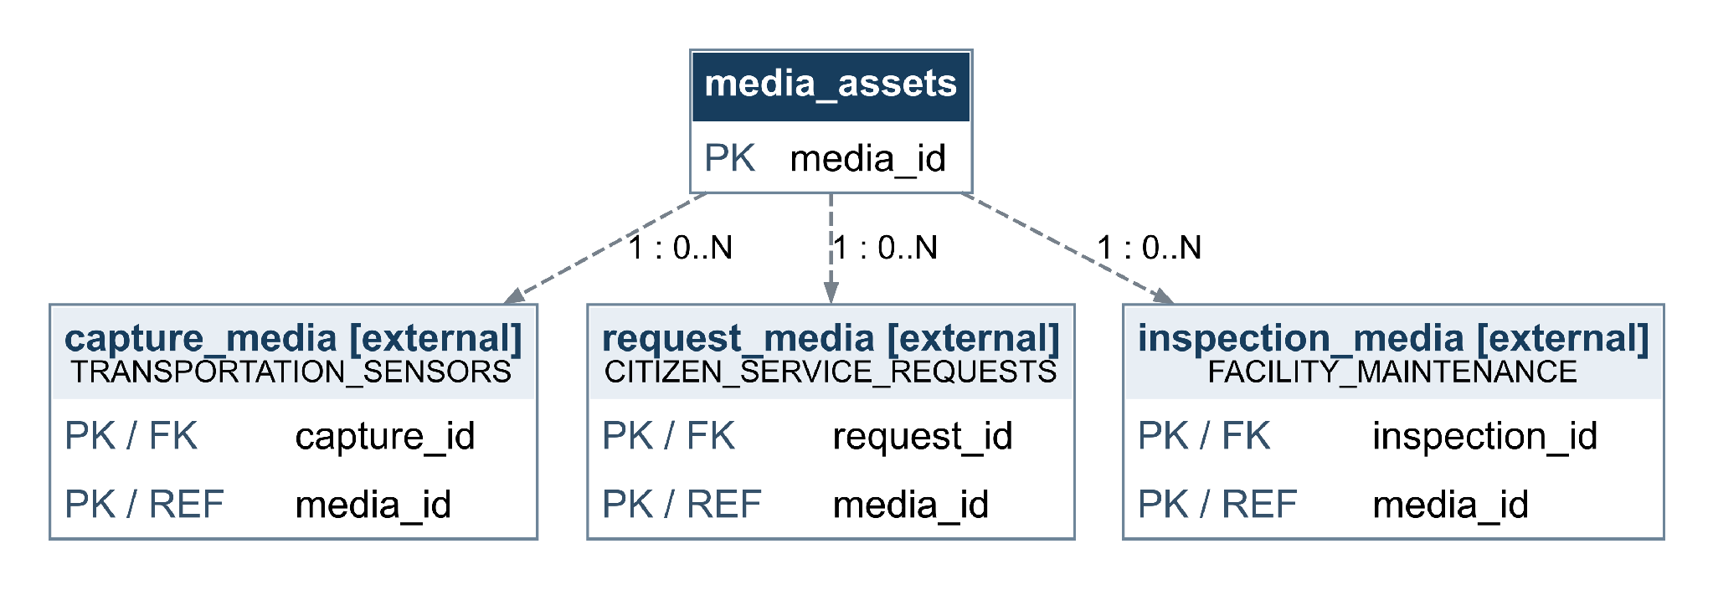
MULTIMEDIA contains only media_assets. capture_media belongs to TRANSPORTATION_SENSORS; request_media belongs to CITIZEN_SERVICE_REQUESTS; inspection_media belongs to FACILITY_MAINTENANCE. These external linking tables reference media_assets. S3 objects are files, not relational tables.

TRANSPORTATION_SENSORS
PK = primary key FK = foreign key (solid line) REF = logical reference (dashed) ID = document identifier Arrow: parent to child. Label: parent count : child count. 1 = one; 0..1 = optional one; 0..N = zero or many.
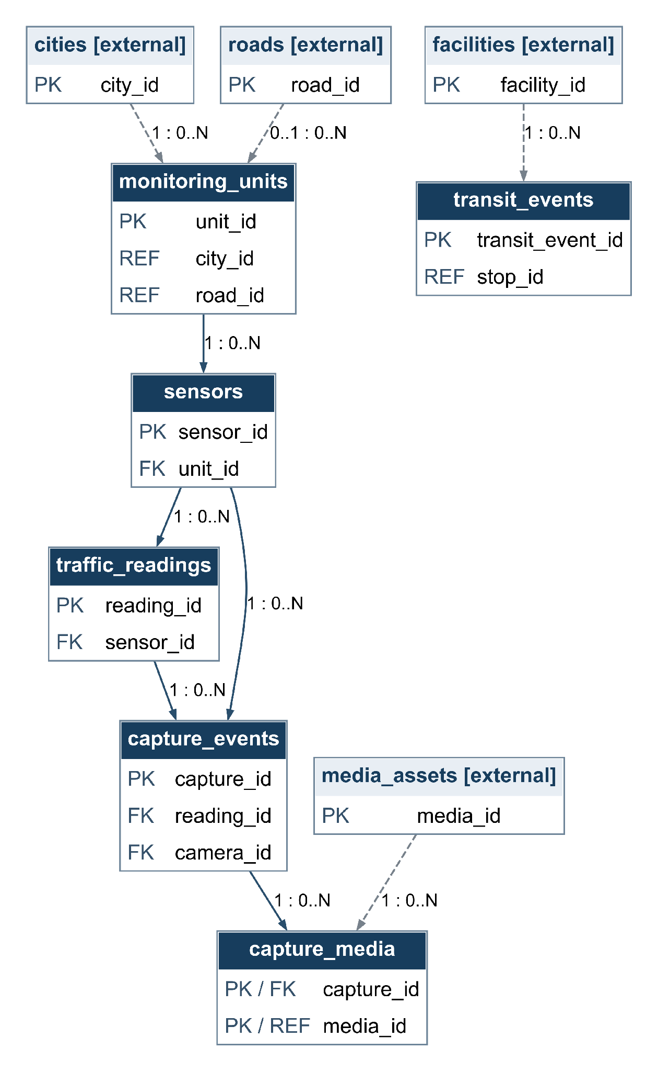
camera_id references a sensor registered as a camera. A reading may have several capture events; reading_id is not unique in capture_events

ENVIRONMENTAL_MONITORING
PK = primary key FK = foreign key (solid line) REF = logical reference (dashed) ID = document identifier
Arrow: parent to child. Label: parent count : child count. 1 = one; 0..1 = optional one; 0..N = zero or many.
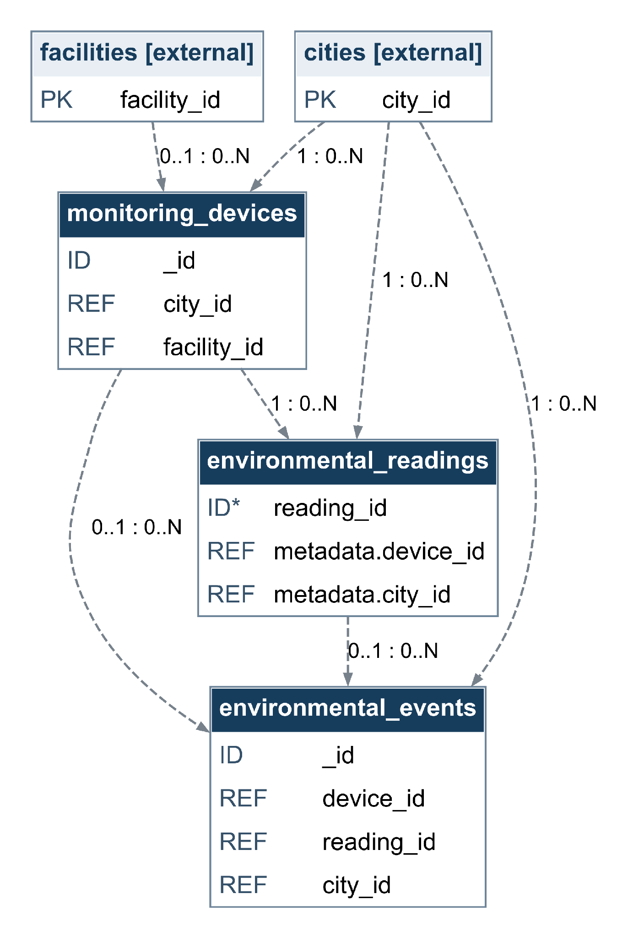
MongoDB collections use logical references, not SQL FKs. ID* reading_id is an application traceability identifier; uniqueness is not enforced by this time-series design.

CITIZEN_SERVICE_REQUESTS
PK = primary key FK = foreign key (solid line) REF = logical reference (dashed) ID = document identifier
Arrow: parent to child. Label: parent count : child count. 1 = one; 0..1 = optional one; 0..N = zero or many.
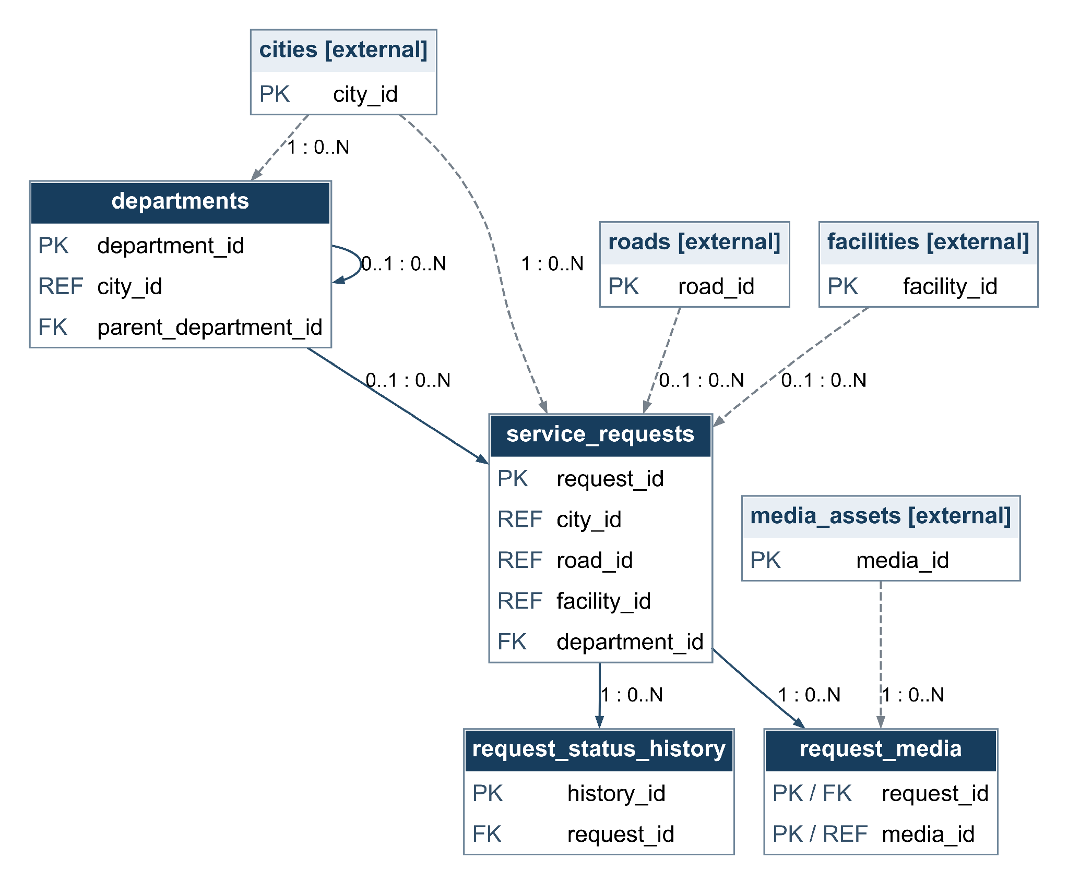
A request may be unassigned and may reference a road or facility. The department hierarchy allows one optional parent and many children; cycles must be prevented.

FACILITY_MAINTENANCE
PK = primary key FK = foreign key (solid line) REF = logical reference (dashed) ID = document identifier
Arrow: parent to child. Label: parent count : child count. 1 = one; 0..1 = optional one; 0..N = zero or many.
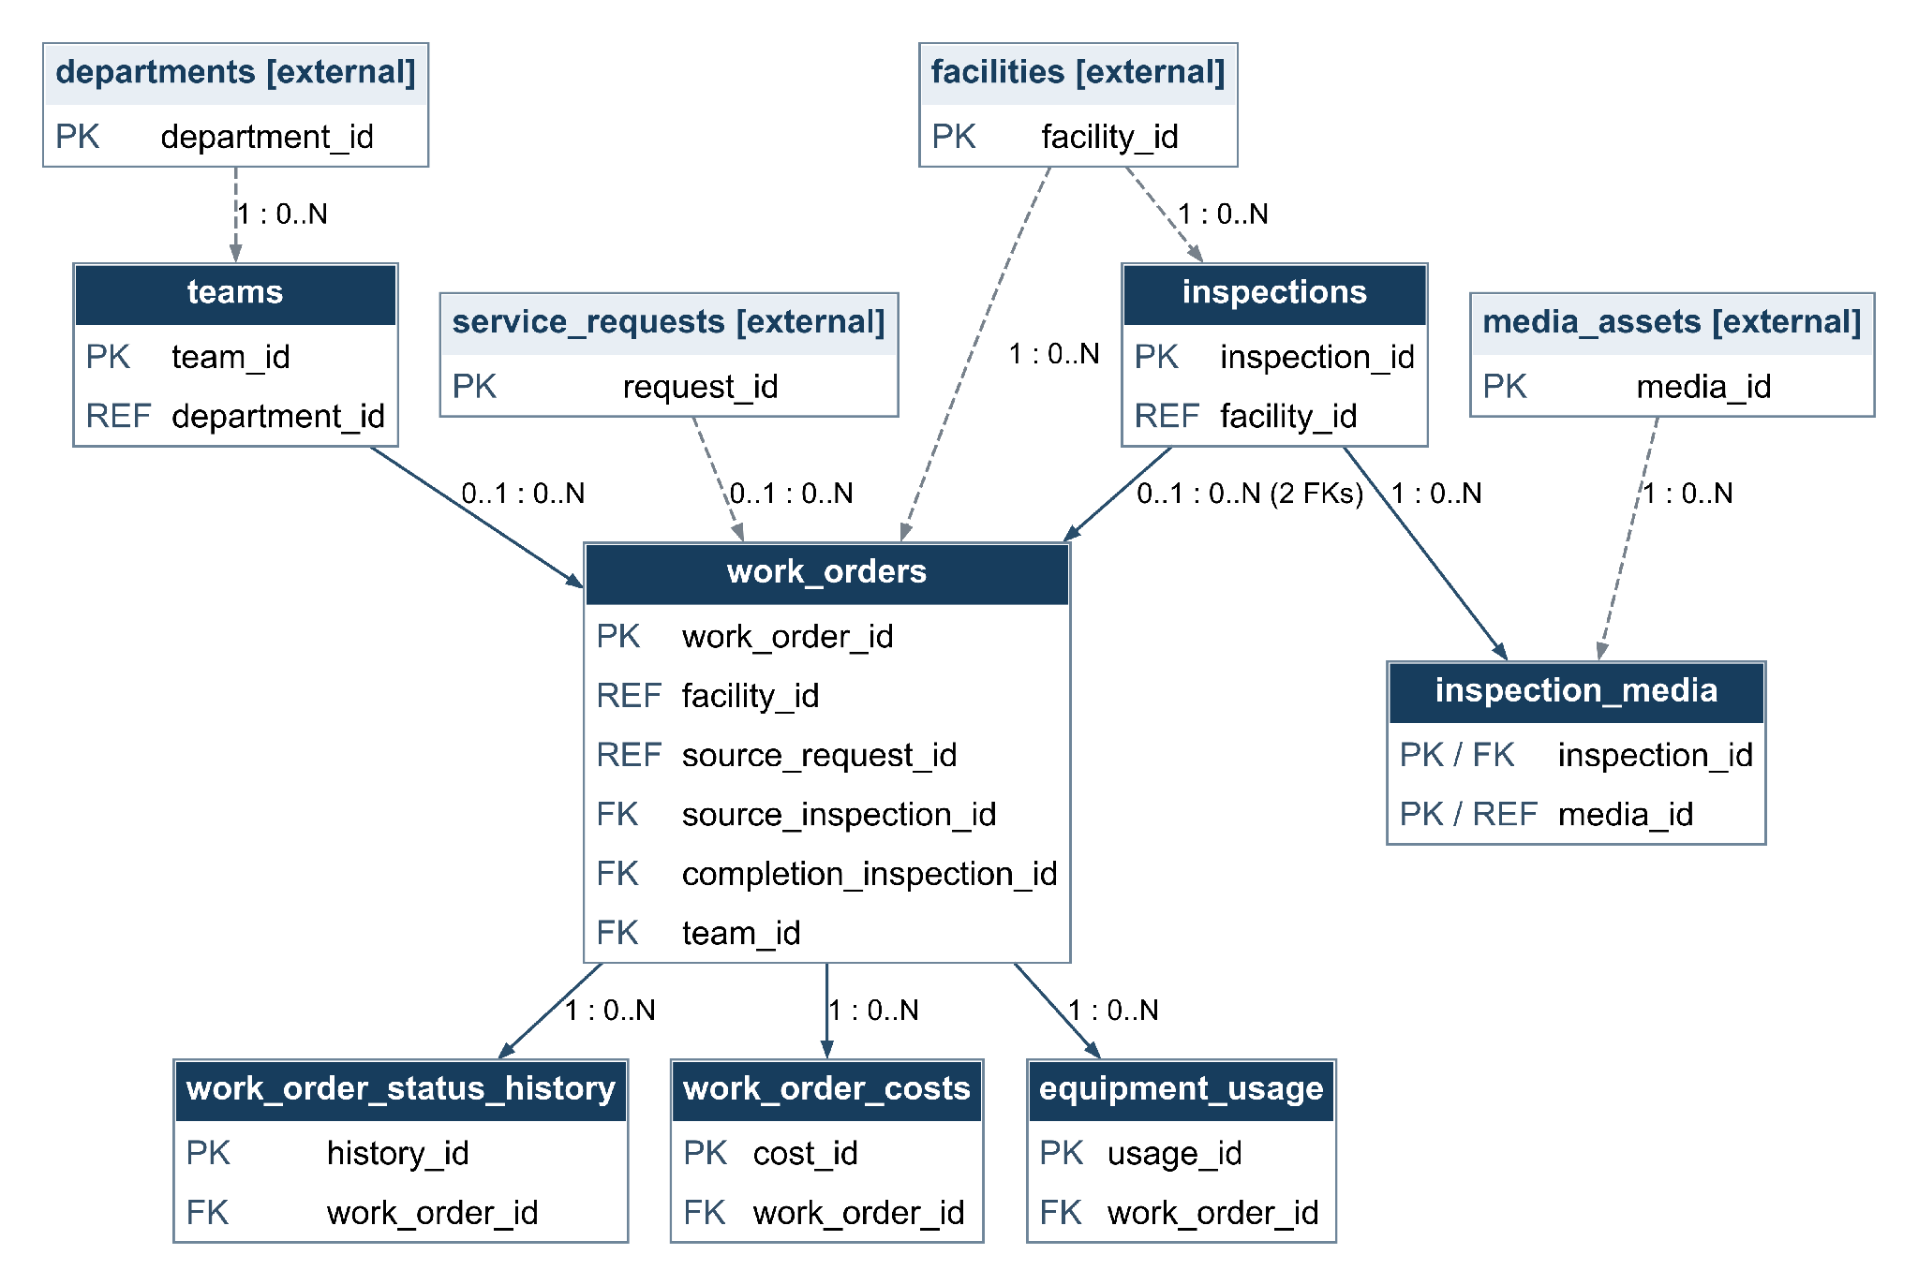
source_inspection_id and completion_inspection_id are separate optional relationships to inspections. Neither field is unique, so neither relationship is one-to-one.

EMERGENCY_RULES_AND_RESPONSE
PK = primary key FK = foreign key (solid line) REF = logical reference (dashed) ID = document identifier
Arrow: parent to child. Label: parent count : child count. 1 = one; 0..1 = optional one; 0..N = zero or many.
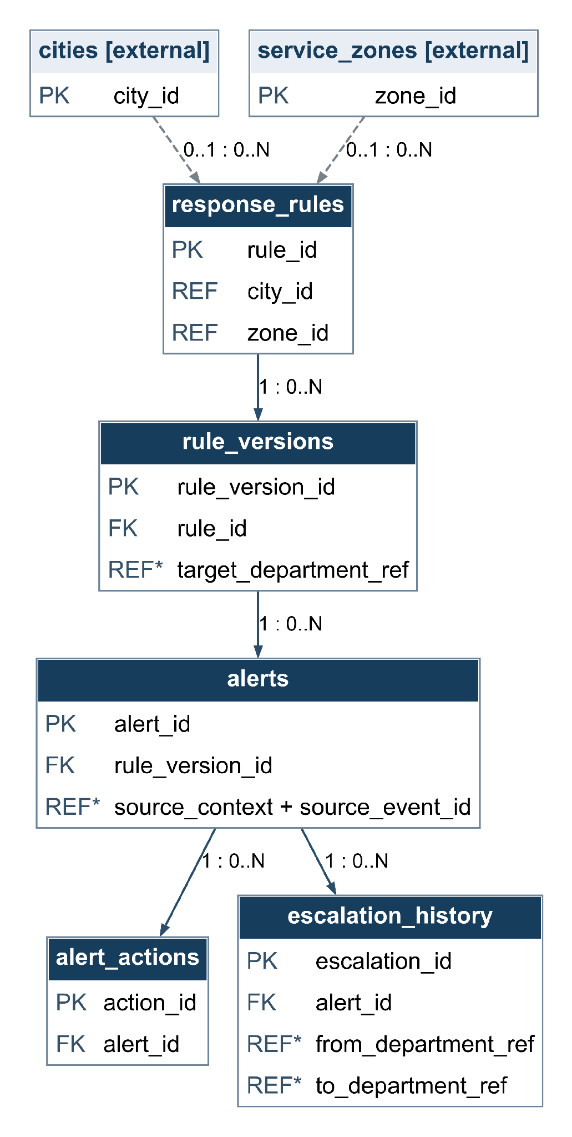
REF* identifies application-managed references. source_context with source_event_id identifies an event in the originating context; it is not a SQL FK. Department references are resolved by the application.

HISTORICAL_PLANNING
PK = primary key FK = foreign key (solid line) REF = logical reference (dashed) ID = document identifier
Arrow: parent to child. Label: parent count : child count. 1 = one; 0..1 = optional one; 0..N = zero or many.
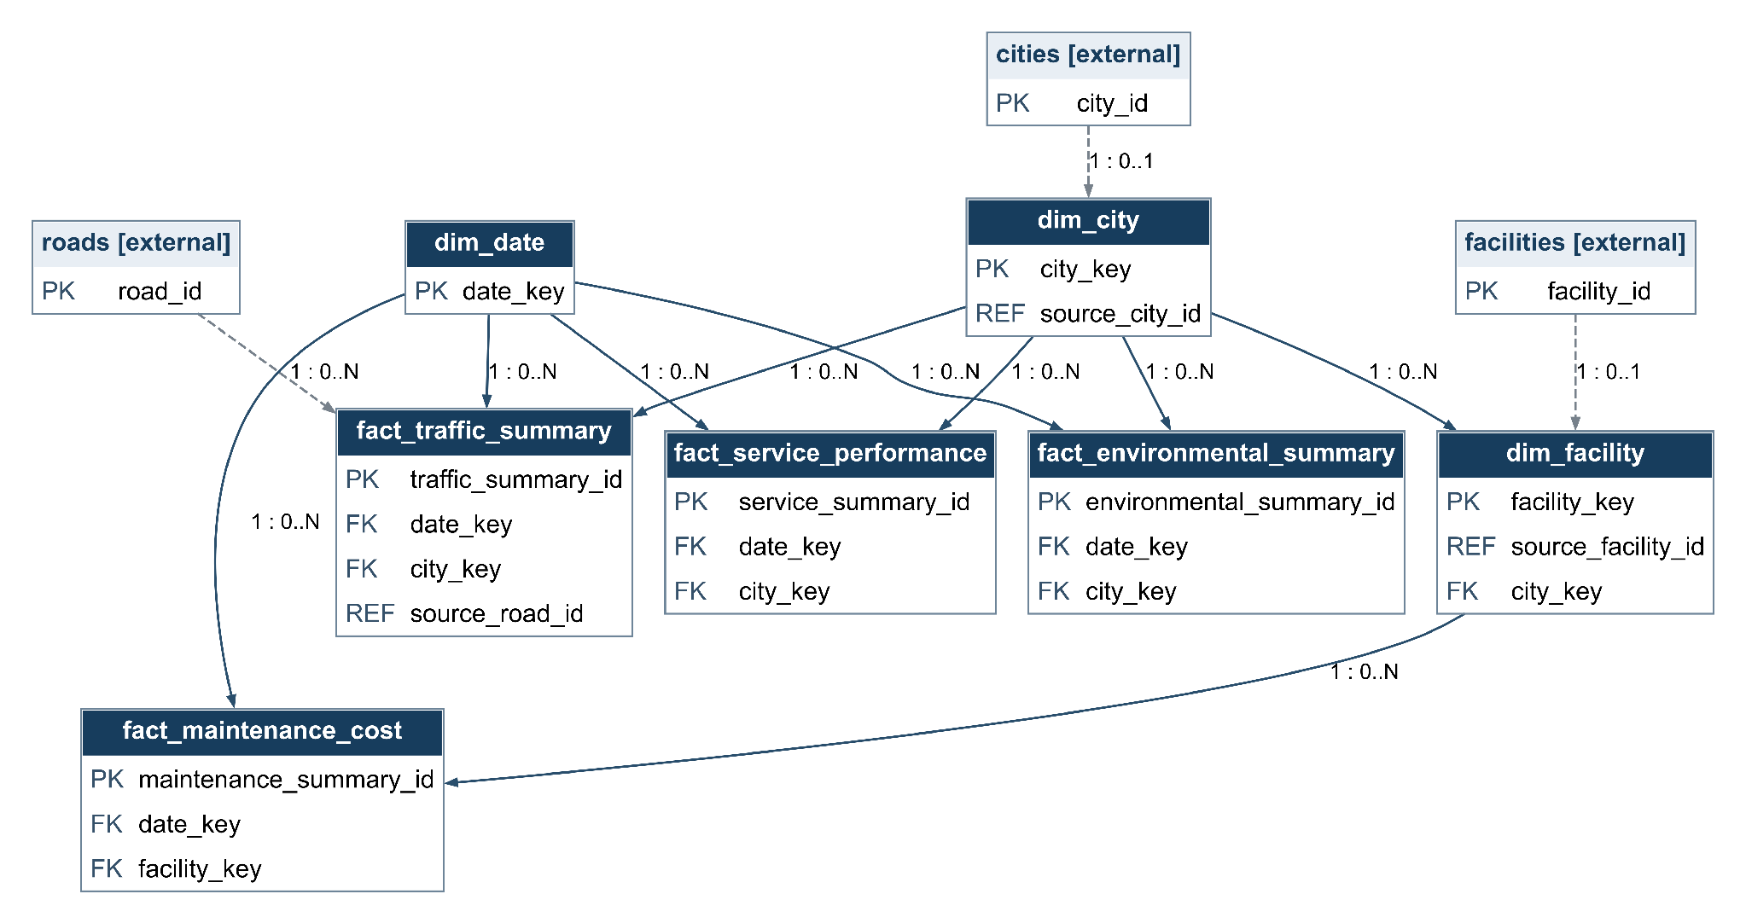
Facts reference shared dimensions. Unique source_city_id and source_facility_id allow at most one current dimension record per source entity. Dashed links show lineage references, not database FKs.

Part 3 – Develop a Storage and Retrieval Strategy
We apply the Part 2 architecture to all eight data sources. The table connects each workload to its stored information, access pattern, storage organisation and performance risk. The accompanying eight scripts implement schema creation and CRUD, including cross-schema relationships, MongoDB documents and multimedia metadata.
Data Source | Data Stored | Creation / Update Frequency | Retrieval Method | Retrieval Frequency / Timing | Primary Storage Purpose | Storage / Retrieval Strategy | Performance Risk
ROAD_AND_FACILITY_LOCATIONS | Cities, roads, facilities, service zones; geometries and optional attributes. | On infrastructure changes; occasional attribute corrections. | By UUID, city, distance, or zone intersection. | Frequent map and operational lookups. | Operational processing. | PostGIS geometries; matching GiST indexes; city indexes. Optional MongoDB documents share UUIDs. | Full spatial scans; mismatched index expressions; dangling cross-store references.
MULTIMEDIA | Images/videos in S3; SQL metadata, checksum, upload state and evidence links. | Per upload; state changes after verification; occasional corrections. | Metadata by media or business-record ID; authorised object retrieval by bucket/key. | On demand; older evidence retrieved occasionally. | Long-term archiving and evidence access. | S3 files plus PostgreSQL catalogue; PK/unique bucket-key; verify upload before availability. | Large transfers delay access; database BLOB growth; metadata/object inconsistency.
TRANSPORTATION_SENSORS | Installations, sensors, readings, transit arrivals, captures and media links. | Readings every few seconds; configuration updated occasionally. | By sensor and time range; join installation to road; transit by stop/time. | Frequent monitoring and historical extraction. | Operational processing. | PostgreSQL; sensor/time indexes; source-event deduplication; JSONB configuration. Evaluate partitioning as volume grows. | Write amplification; unbounded history scans; duplicate ingestion.
ENVIRONMENTAL_MONITORING | Device documents, metric/unit readings, quality flags and observed events. | Continuous readings; occasional configuration/event updates. | By device, metric and time; devices by geographic proximity. | Near-real-time monitoring and historical trends. | Operational processing. | MongoDB regular device/event collections; time-series readings indexed by device/time; application validation. | Oversized scans; poor bucketing; duplicate readings; unsupported time-series update patterns.

Storage and Retrieval Strategy Continued
Data Source | Data Stored | Creation / Update Frequency | Retrieval Method | Retrieval Frequency / Timing | Primary Storage Purpose | Storage / Retrieval Strategy | Performance Risk
CITIZEN_SERVICE_REQUESTS | Requests, departments, priorities, assignments, status history and media links. | Each citizen report; updates during triage and resolution. | By request UUID/tracking number; queues by city, status and department. | Frequent during service delivery. | Operational processing. | PostgreSQL transactions; PK/unique tracking number; queue index; row lock and atomic status/history changes. | Slow queues; lost updates; inconsistent current state and history.
FACILITY_MAINTENANCE | Inspections, work orders, teams, costs, equipment usage and evidence links. | Per inspection/order; updated during work; costs as incurred. | By facility, order, team, status or period; costs by currency. | Frequent operations; occasional facility-history reviews. | Operational processing. | PostgreSQL FKs across shared schemas; facility/time and status indexes; transactional progress history. | Slow joins; contention; orphaned costs; incorrect totals across currencies.
EMERGENCY_RULES_AND_RESPONSE | Policies, immutable approved versions, alerts, actions and escalation history. | Rules change occasionally; alerts/actions arrive on events. | Effective approved rules by scope; alerts by status/time; history by alert ID. | Event-driven, with prompt queue retrieval. | Operational processing. | PostgreSQL versioned rules and unique evaluation keys; external evaluation service; indexed alert queue. | Duplicate alerts; burst backlog; evaluating stale/unapproved rules.
HISTORICAL_PLANNING | Date/city/facility dimensions; daily traffic, environmental, service and cost facts. | Scheduled daily refresh; rerun affected dates for corrections. | By reporting period, city, road, category, facility, metric/unit or currency. | Scheduled dashboards and occasional historical analysis. | Analytical processing. | Separate PostgreSQL database; load dimensions first; unique fact grains and idempotent upserts. | Reporting competes with operations if combined; duplicated facts; stale or incomparable aggregates.

Storage and Retrieval Justification
We selected all eight sources because the platform combines structured transactions, temporal observations, geographic searches, files and historical analysis. Each source requires a storage approach that matches how records arrive and how applications retrieve them. We retain the technologies chosen in Part 2: PostgreSQL for operational records, PostGIS for geographic data, MongoDB for environmental information and optional location attributes, S3 for files, and a separate PostgreSQL analytical database.
Locations provide shared identifiers for the other operational contexts. PostGIS stores points, road lines and service-zone polygons, while spatial indexes support nearby-facility and intersection queries. The distance example uses a geography expression index matching its query expression so distances are measured in metres. Optional MongoDB attribute documents reuse the relational UUID as their document identifier. The MongoDB script checks an exported SQL identifier snapshot before creating a document.
Citizen requests and maintenance records need reliable relationships and coordinated updates. Their schemas share the operational PostgreSQL database, allowing actual foreign keys between requests, departments, facilities, inspections and work orders. Composite references also check municipality or facility consistency where relevant. Status changes lock the current row and record the corresponding history within one transaction. Queue and facility-history indexes support common retrieval patterns, while monetary summaries remain separated by currency.
Transportation readings arrive much more often than device configurations change. We index sensor identifiers with observation timestamps and retrieve bounded time ranges, avoiding unnecessary scans of the complete history. Source-event uniqueness prevents repeated SQL ingestion. Monthly partitioning remains a volume-driven extension rather than an implemented requirement. Environmental readings use a MongoDB time-series collection, with regular collections for device configuration and observed events. Because time-series validation and updates have restrictions, the script validates measurements before insertion and demonstrates updates only to series metadata.
Multimedia separates large file contents from searchable metadata. S3 stores the objects, while PostgreSQL records identifiers, storage keys, checksums and upload states. Files become available only after successful transfer and verification. Request, inspection and capture linking tables preserve the business context. PostgreSQL and S3 cannot commit atomically together, so failures require visible states, retries and reconciliation. The same limitation applies to references crossing PostgreSQL and MongoDB; an application check is not a distributed foreign key.
Emergency response stores approved rule versions and links each alert to the exact version evaluated. An external service performs evaluation; unique evaluation keys prevent duplicate alerts. Historical planning instead loads shared dimensions before daily facts in a separate database. Idempotent upserts preserve each fact grain, reporting dates use one documented timezone, and environmental units remain explicit. This separation protects operational work from broad reporting scans. Native SQL and mongosh scripts demonstrate CRUD while retaining shared examples for later contexts. Retention periods, ingestion capacity and latency targets require stakeholder validation and workload measurements before production deployment.

Implementation and Execution Order
The operational schemas share srsp_operational; the historical schema uses srsp_analytics. MongoDB databases are srsp_location_attributes and srsp_environment. Script 02 stores the S3 bucket and object key as metadata; the upload service handles the files separately. All eight scripts are available in the project’s GitHub repository under part3/scripts (main branch); the table links directly to each file (mehrthur-teste, n.d.).
Order | Context | Executable script
01 | Locations | 01_road_and_facility_locations.sql
02 | Multimedia | 02_multimedia.sql
03 | Transportation | 03_transportation_sensors.sql
04 | Environment | 04_environmental_monitoring.js
05 | Citizen requests | 05_citizen_service_requests.sql
06 | Maintenance | 06_facility_maintenance.sql
07 | Emergency response | 07_emergency_rules_and_response.sql
08 | Historical planning | 08_historical_planning.sql
Run scripts 01–08 in order using psql and mongosh as described in part3/README.md. The scripts use concrete demonstration values; application integrations should bind submitted values as parameters. UUIDs identify operational records; MongoDB stores shared UUIDs as strings. Primary keys, unique constraints, checks and foreign keys protect the relational model. CREATE SCHEMA, CREATE TABLE and CREATE INDEX use IF NOT EXISTS. Database creation checks the catalogue because PostgreSQL has no CREATE DATABASE IF NOT EXISTS syntax.
Seven native PostgreSQL SQL files and one native mongosh JavaScript file implement all eight sources. Each SQL table has explicit INSERT, SELECT, UPDATE and DELETE statements. The MongoDB file also implements optional location attributes. Disposable records demonstrate deletion while retaining shared parents. Existing schemas require explicit migrations if their structure differs; IF NOT EXISTS does not repair incompatible tables.
The following SQL and MongoDB examples illustrate one representative record per source. They assume the tables and parent records already created by the executable scripts. Named values such as :request_id are application parameters; substitute bound values through the relevant driver. Run the DELETE examples only on disposable demonstration records. Full scripts also cover the supporting tables and collection validation.

CRUD Example 1 Road and Facility Locations
Executable script: 01_road_and_facility_locations.sql
PostGIS stores core geography; optional MongoDB attribute documents use the same UUID and are validated against SQL parents.
-- CREATE a facility linked to an existing city
INSERT INTO road_and_facility_locations.facilities
(facility_id, city_id, name, facility_type, status, location)
VALUES (:facility_id, :city_id, 'Demo park', 'park',
'operational', ST_SetSRID(ST_MakePoint(-79.38,43.65),4326));

-- READ facilities within 1 kilometre
SELECT facility_id, name
FROM road_and_facility_locations.facilities
WHERE ST_DWithin(location::geography,
ST_SetSRID(ST_MakePoint(-79.38,43.65),4326)::geography,1000);

-- UPDATE descriptive information
UPDATE road_and_facility_locations.facilities
SET name='Reviewed park', updated_at=now()
WHERE facility_id=:facility_id;

-- DELETE only an unreferenced demonstration facility
DELETE FROM road_and_facility_locations.facilities
WHERE facility_id=:facility_id;

CRUD Example 2 Multimedia
Executable script: 02_multimedia.sql
The SQL script implements catalogue CRUD. Seed metadata remains pending because no object is uploaded by SQL. The upload service performs S3 PutObject, GetObject and DeleteObject, then verifies the checksum before marking a file available.
-- CREATE metadata before uploading the S3 object
INSERT INTO multimedia.media_assets
(media_id,media_type,mime_type,original_filename,size_bytes,
source_channel,storage_bucket,storage_key,upload_status)
VALUES (:media_id,'image','image/png','evidence.png',:size,
'citizen_portal',:bucket,:object_key,'pending');

-- READ the catalogue entry
SELECT media_id,storage_bucket,storage_key,upload_status
FROM multimedia.media_assets WHERE media_id=:media_id;

-- UPDATE only after successful upload and checksum verification
UPDATE multimedia.media_assets
SET upload_status='available',checksum_sha256=:checksum
WHERE media_id=:media_id;

-- Before file deletion, mark unavailable and unlink consumers.
-- Delete the S3 object, then DELETE its disposable metadata.
DELETE FROM multimedia.media_assets WHERE media_id=:media_id;

CRUD Example 3 Transportation Sensors
Executable script: 03_transportation_sensors.sql
A reading belongs to a sensor, which belongs to a monitoring unit and road. Source-event uniqueness prevents duplicate ingestion. The full script includes transit and camera evidence.
-- CREATE a reading for an existing sensor
INSERT INTO transportation_sensors.traffic_readings
(reading_id,sensor_id,source_event_id,recorded_at,
measurement_type,numeric_value,unit)
VALUES (:reading_id,:sensor_id,:source_event_id,:recorded_at,
'speed',62.5,'km/h');

-- READ a bounded sensor history
SELECT recorded_at,numeric_value,unit
FROM transportation_sensors.traffic_readings
WHERE sensor_id=:sensor_id
AND recorded_at>=:start_time AND recorded_at<:end_time
ORDER BY recorded_at DESC LIMIT 100;

-- UPDATE a corrected disposable reading
UPDATE transportation_sensors.traffic_readings
SET numeric_value=61.0 WHERE reading_id=:reading_id;

-- DELETE after removing any dependent capture links/events
DELETE FROM transportation_sensors.traffic_readings
WHERE reading_id=:reading_id;

CRUD Example 4 Environmental Monitoring
Executable script: 04_environmental_monitoring.js
The native mongosh script creates and validates regular collections and creates the time-series collection. It implements device/event CRUD and reading insertion, bounded retrieval, metadata update and temporary-series deletion. Optional location-attribute CRUD is included in the same file.
// CREATE a regular device document
const env = db.getSiblingDB('srsp_environment');
env.monitoring_devices.insertOne({
_id: deviceId, city_id: cityId,
location: {type:'Point',coordinates:[-79.3832,43.6532]},
status:'active',
configuration:{sampling_interval_seconds:10,
metrics:[{metric:'temperature',unit:'degC'}]},
updated_at:new Date()
});

// READ
env.monitoring_devices.findOne({_id:deviceId});

// UPDATE
env.monitoring_devices.updateOne({_id:deviceId},
{$set:{status:'maintenance',updated_at:new Date()}});

// DELETE only after clearing reading/event references
env.monitoring_devices.deleteOne({_id:deviceId});

CRUD Example 5 Citizen Service Requests
Executable script: 05_citizen_service_requests.sql
The full SQL script includes departments, requests, status history and media links. The demonstrated transition locks a disposable request and changes its expected previous state together with history in one transaction.
-- CREATE with existing city, department and optional facility
INSERT INTO citizen_service_requests.service_requests
(request_id,tracking_number,city_id,department_id,
category,description,location,priority,status)
VALUES (:request_id,:tracking_number,:city_id,:department_id,
'broken_streetlight','Broken light',:point,'normal','submitted');

-- READ by public tracking reference
SELECT * FROM citizen_service_requests.service_requests
WHERE tracking_number=:tracking_number;

-- UPDATE state and history in one transaction after validation
BEGIN;
SELECT status FROM citizen_service_requests.service_requests
WHERE request_id=:request_id FOR UPDATE;
UPDATE citizen_service_requests.service_requests
SET status='triaged',updated_at=now() WHERE request_id=:request_id;
INSERT INTO citizen_service_requests.request_status_history
(history_id,request_id,from_status,to_status,changed_by_ref)
VALUES (:history_id,:request_id,'submitted','triaged',:actor);
COMMIT;

-- DELETE a disposable child history before its parent
DELETE FROM citizen_service_requests.request_status_history
WHERE request_id=:request_id;
DELETE FROM citizen_service_requests.service_requests
WHERE request_id=:request_id;

CRUD Example 6 Facility Maintenance
Executable script: 06_facility_maintenance.sql
Work orders can reference a request and source inspection; preventive orders may omit both. Completion needs a satisfactory verification inspection for the same facility. Status transitions also write history atomically.
-- CREATE with existing facility, team and optional request
INSERT INTO facility_maintenance.work_orders
(work_order_id,facility_id,source_request_id,team_id,
description,maintenance_type,priority,status)
VALUES (:work_order_id,:facility_id,:request_id,:team_id,
'Repair light','corrective','normal','open');

-- READ a facility history
SELECT work_order_id,status,created_at
FROM facility_maintenance.work_orders
WHERE facility_id=:facility_id ORDER BY created_at DESC;

-- UPDATE the descriptive scope
UPDATE facility_maintenance.work_orders
SET description='Replace damaged light',updated_at=now()
WHERE work_order_id=:work_order_id;

-- DELETE a disposable unreferenced work order
-- Remove its costs, equipment usage and status history first.
DELETE FROM facility_maintenance.work_orders
WHERE work_order_id=:work_order_id;

CRUD Example 7 Emergency Rules and Response
Executable script: 07_emergency_rules_and_response.sql
Approved versions are immutable. The CRUD update uses a draft version; alerts retain a reference to an approved effective version. The service validates source events and responding departments.
-- CREATE an editable draft for an existing rule
INSERT INTO emergency_rules_and_response.rule_versions
(rule_version_id,rule_id,version_number,conditions,priority,
target_department_ref,approval_status,effective_from)
VALUES (:version_id,:rule_id,:version_number,
'{"metric":"speed","operator":">","threshold":60,"unit":"km/h"}',
'high',:department_ref,'draft',:effective_from);

-- READ the rule version
SELECT * FROM emergency_rules_and_response.rule_versions
WHERE rule_version_id=:version_id;

-- UPDATE only a draft; published versions require a new version
UPDATE emergency_rules_and_response.rule_versions
SET conditions=jsonb_set(conditions,'{threshold}','65')
WHERE rule_version_id=:version_id AND approval_status='draft';

-- DELETE an unreferenced disposable draft
DELETE FROM emergency_rules_and_response.rule_versions
WHERE rule_version_id=:version_id AND approval_status='draft';

CRUD Example 8 Historical Planning
Executable script: 08_historical_planning.sql
Connect to srsp_analytics. Load dimensions before facts and map source UUIDs to local surrogate keys. No foreign key or SQL join crosses the operational and analytical databases.
-- CREATE a daily fact after loading its date/city dimensions
INSERT INTO historical_planning.fact_traffic_summary
(date_key,city_key,source_road_id,speed_sample_count,
average_speed_kmh,loaded_at)
VALUES (:date_key,:city_key,:road_id,100,45.5,now())
ON CONFLICT (date_key,city_key,source_road_id) DO NOTHING;

-- READ by reporting period and city
SELECT d.calendar_date,f.average_speed_kmh,f.loaded_at
FROM historical_planning.fact_traffic_summary f
JOIN historical_planning.dim_date d USING(date_key)
WHERE f.city_key=:city_key
AND d.calendar_date BETWEEN :start_date AND :end_date;

-- UPDATE a recomputed daily value without duplicating its grain
UPDATE historical_planning.fact_traffic_summary
SET speed_sample_count=101,average_speed_kmh=45.7,loaded_at=now()
WHERE date_key=:date_key AND city_key=:city_key
AND source_road_id=:road_id;

-- DELETE only the disposable demonstration fact
DELETE FROM historical_planning.fact_traffic_summary
WHERE date_key=:date_key AND city_key=:city_key
AND source_road_id=:road_id;

Part 4 – Index Selection and Validation
Table 1 presents indexing strategies for eight Smart Regional Services Platform retrieval scenarios. We reuse matching Part 3 indexes and propose targeted additions for an ordered citizen backlog, geometry containment, environmental threshold searches and an urgent alert queue. Each recommendation connects an access pattern with its retrieval benefit and maintenance cost.
Table 1
Recommended Indexing Strategies for the Smart Regional Services Platform
Retrieval scenario | Table / collection | Search condition / access pattern | Recommended index fields | Supported access type | Retrieval benefit | Trade-off / maintenance cost
1. Find open citizen requests in a city, showing creation date/time, oldest first. | service_requests  (PostgreSQL) | Match city_id and status IN ('submitted', 'triaged', 'assigned', 'in_progress'). Return created_at; ORDER BY created_at ASC, request_id ASC. | Propose partial B-tree (city_id, created_at, request_id) WHERE status IN the four active values. Existing request_queue_idx supports filtering with a separate sort. | Equality on city; active-status subset; chronological retrieval. | The partial index groups active requests by city in creation order and supports stable timestamp ties. It can avoid the global sort needed with the existing city/status/department/date index. | Add only if backlog retrieval is frequent and selective. Extra storage and writes accompany inserts/deletes and transitions into or out of active statuses. Retain the general queue index for its separate workload.
2. Retrieve one traffic sensor’s readings during a selected period, newest first. | traffic_readings  (PostgreSQL) | Match sensor_id; recorded_at >= :start_time AND recorded_at < :end_time. ORDER BY recorded_at DESC. | Reuse traffic_sensor_time_idx: composite B-tree (sensor_id, recorded_at DESC). | Equality; temporal range; ordered retrieval. | Locates one sensor’s entries and scans the requested time interval in descending order. Reduces irrelevant history scans and can avoid a separate sort. | Each incoming reading adds an index entry, increasing storage and ingestion work. Time partitioning remains an option to evaluate, rather than an implemented feature.
3. Find facilities in a selected zone, nearest to farthest from a selected or incident location. | facilities;  service_zones  (PostGIS) | Match zone_id/city; ST_Covers(z.boundary, f.location). Calculate ST_Distance using geography and the selected point. Return metres; sort by distance, then facility_id. | Add GiST (location) on facilities. Reuse the service_zones primary-key B-tree (zone_id) to select the zone. | Equality; spatial containment; distance-ordered retrieval. | The zone key and proposed geometry GiST reduce containment candidates before exact checks. Distances are calculated for matching facility points, then explicitly sorted (PostGIS Project, n.d.‑b, n.d.‑c). | The geometry index adds storage and location-update work. Distance calculation and sorting still cost CPU/memory; the containment index does not remove that sort. Existing geography indexing serves other distance patterns.
4. Retrieve a facility’s work orders created during the last two years, newest first. | work_orders  (PostgreSQL) | Match facility_id; created_at >= :as_of minus two years AND created_at <= :as_of. ORDER BY created_at DESC. Include all work-order statuses. | Reuse work_facility_time_idx: composite B-tree (facility_id, created_at DESC). | Equality; temporal range; ordered retrieval. | Narrows retrieval to one facility and the required creation-date interval. Can return matching work orders newest first without a separate sort. | Consumes storage and requires maintenance for inserts, deletes and indexed-field changes. Completion-date or inspection-date searches require a separately matched access path.
5. Retrieve available multimedia evidence attached to one citizen request. | request_media;  media_assets  (PostgreSQL);  files in S3 | Match request_id; join on media_id; filter upload_status = 'available'. Use the returned bucket/key for authorised S3 retrieval. | Reuse primary-key B-trees: request_media (request_id, media_id) and media_assets (media_id). No additional index is required. | Equality; indexed join; availability filtering. | Finds attachment links by request and supports direct metadata lookups by media ID. Checks availability on matching assets before returning file references. | Existing key indexes consume storage and require maintenance on inserts/deletes. Their reuse adds no new index cost. S3 transfer time and metadata/object reconciliation remain separate concerns.
6. Find valid environmental readings above a threshold for one metric and unit in a city during a selected period. | environmental_  readings  (MongoDB time-series) | Match metadata.city_id, metadata.metric and metadata.unit; recorded_at in [start, end); value > :threshold; quality_status = 'valid'. | Propose compound index: metadata.city_id: 1; metadata.metric: 1; metadata.unit: 1; recorded_at: -1. Retain device_time_idx for per-device retrieval. | Metadata equality; temporal range; threshold filtering. | Narrows candidate buckets by city, metric, unit and time before checking individual values and quality. Threshold and quality remain residual filters (MongoDB, Inc., n.d.‑d). | An additional index increases bucket-index storage and ingestion work. Large time windows still examine many readings; confirm selectivity before adoption. It does not enforce reading uniqueness.
7. Retrieve unacknowledged urgent emergency alerts, oldest first, for prompt operator attention. | alerts  (PostgreSQL) | status = 'open' AND priority = 'urgent'; ORDER BY triggered_at ASC LIMIT :page_size. Keep these two status/priority values explicit in the query. | Propose partial B-tree on (triggered_at) WHERE status = 'open' AND priority = 'urgent'. Existing alert_queue_idx supports the general status queue. | Equality on status/priority; ordered retrieval from a partial index. | If open urgent alerts are a small subset, indexes only that queue and supports oldest-first retrieval without scanning other priorities. The query must imply the index predicate (PostgreSQL Global Development Group, n.d.‑e). | Adopt only for a frequent, selective urgent queue. Status/priority changes add or remove entries; bursts can reduce selectivity. The general queue index still needs maintenance.
8. Locate active environmental monitoring devices near an incident, nearest first. | monitoring_  devices  (MongoDB regular collection) | Use location.$near with a GeoJSON incident point and $maxDistance in metres; filter status = 'active'; limit results. Coordinates use longitude, latitude. | Reuse device_location_geo: {location: '2dsphere'}. The index covers device positions, not the time-series readings. | Spatial proximity; distance-ordered retrieval; status filtering. | Supports spherical proximity search and nearest-first results, then retains active devices. Reuses a different spatial access method from PostGIS zone containment (MongoDB, Inc., n.d.‑a, n.d.‑e). | Consumes storage and requires maintenance when devices move or are inserted/deleted. Status is a residual filter; many nearby inactive devices can increase work. Missing locations have no spatial index entry.
Note. GiST = Generalized Search Tree; DESC = descending order; S3 = Amazon Simple Storage Service.

Index Design Rationale
Composite key order follows the query: equality fields lead the time range in scenarios 2 and 4. In scenario 1, the existing city/status queue index filters active requests but does not supply a global creation-date order. The proposed partial index leads with city and creation time and adds request_id for stable ties; adopt it when workload evidence justifies another index (PostgreSQL Global Development Group, n.d.-d, n.d.-e). Scenario 5 reuses primary-key indexes (PostgreSQL Global Development Group, n.d.-a). In scenario 3, GiST supports containment filtering, while geographic distance in metres is calculated and sorted separately. Neither query requires an index on every returned field.
Validate proposed additions with representative city sizes, time windows and write rates. Compare query plans, rows or buckets examined, sorting, index size and ingestion cost. Use PostgreSQL EXPLAIN (ANALYZE, BUFFERS) for read queries and MongoDB explain("executionStats"). Retain additions only when retrieval gains justify maintenance; broad result sets may favour scans. These are design recommendations, not measured performance results. The scenarios use operational stores; the final Redshift analytical recommendation requires its own physical design.

Example Retrieval Queries
The six SQL and two mongosh examples use replaceable sample inputs. SQL targets srsp_operational; MongoDB targets srsp_environment. The queries and proposed indexes require server-side validation.

Scenario 1: Open Requests in a City From Oldest to Newest
SELECT
request_id,
tracking_number,
status,
department_id,
created_at
FROM citizen_service_requests.service_requests
WHERE city_id = UUID '00000000-0000-0000-0000-000000000001'
AND status IN (
'submitted',
'triaged',
'assigned',
'in_progress'
)
ORDER BY created_at ASC, request_id ASC;
Returns creation date/time; request_id breaks timestamp ties. The existing queue index filters but needs a global sort. The proposed active-request partial index (city_id, created_at, request_id) can support the requested order when justified by workload.

Scenario 2: Sensor Readings During a Period
SELECT
reading_id,
recorded_at,
measurement_type,
numeric_value,
unit
FROM transportation_sensors.traffic_readings
WHERE sensor_id = UUID '00000000-0000-0000-0000-000000000015'
AND recorded_at >= TIMESTAMPTZ '2026-10-23 00:00:00+00'
AND recorded_at < TIMESTAMPTZ '2026-10-24 00:00:00+00'
ORDER BY recorded_at DESC;
Matches traffic_sensor_time_idx(sensor_id, recorded_at DESC). The exclusive end avoids overlap between consecutive periods.

Scenario 3: Facilities in a Zone From Nearest to Farthest
SELECT
f.facility_id,
f.name,
f.facility_type,
ST_Distance(
f.location::geography,
'SRID=4326;POINT(-79.3832 43.6532)'::geography
) AS distance_metres
FROM road_and_facility_locations.service_zones AS z
JOIN road_and_facility_locations.facilities AS f
ON f.city_id = z.city_id
AND ST_Covers(z.boundary, f.location)
WHERE z.zone_id = UUID '00000000-0000-0000-0000-000000000005'
ORDER BY distance_metres ASC, f.facility_id ASC;
Replace the sample longitude/latitude with the selected or incident location. ST_Covers includes boundary points and the city condition preserves zone ownership. The proposed GiST(location) filters spatial candidates; ST_Distance on geography calculates spheroidal distance in metres, followed by an explicit sort. This is geographic distance, not driving distance. facility_id breaks distance ties consistently.

Scenario 4: Facility Work Orders Over Two Years
SELECT
work_order_id,
status,
maintenance_type,
created_at
FROM facility_maintenance.work_orders
WHERE facility_id = UUID '00000000-0000-0000-0000-000000000003'
AND created_at >=
TIMESTAMPTZ '2026-10-24 00:00:00+00' - INTERVAL '2 years'
AND created_at <= TIMESTAMPTZ '2026-10-24 00:00:00+00'
ORDER BY created_at DESC;
Matches work_facility_time_idx(facility_id, created_at DESC). The fixed as-of instant makes the example repeatable; replace both occurrences together. All statuses are included.

Scenario 5: Available Evidence for a Request
SELECT
m.media_id,
rm.evidence_role,
m.media_type,
m.original_filename,
m.storage_bucket,
m.storage_key
FROM citizen_service_requests.request_media AS rm
JOIN multimedia.media_assets AS m
ON m.media_id = rm.media_id
WHERE rm.request_id = UUID '00000000-0000-0000-0000-00000000001f'
AND m.upload_status = 'available';
Reuses request_media(request_id, media_id) and media_assets(media_id) primary-key indexes. Availability is checked on matching metadata; the application authorises S3 access. Part 3 seed uploads remain pending, so an empty result is expected until verified uploads are available.

Scenario 6: Environmental Readings Above a Threshold
db.getSiblingDB("srsp_environment").environmental_readings.find(
{
"metadata.city_id": "00000000-0000-0000-0000-000000000001",
"metadata.metric": "temperature",
"metadata.unit": "degC",
recorded_at: {
$gte: ISODate("2026-10-23T00:00:00Z"),
$lt: ISODate("2026-10-24T00:00:00Z")
},
value: { $gt: 20 },
quality_status: "valid"
},
{
_id: 0,
reading_id: 1,
recorded_at: 1,
value: 1,
metadata: 1
}
);
Illustrates a temperature threshold of 20 degrees Celsius, not an emergency policy. The proposed city/metric/unit/time index narrows candidate buckets; value and quality remain residual filters.

Scenario 7: Unacknowledged Urgent Alerts
SELECT
alert_id,
source_context,
source_event_id,
triggered_at
FROM emergency_rules_and_response.alerts
WHERE status = 'open'
AND priority = 'urgent'
ORDER BY triggered_at ASC
LIMIT 50;
The literal status/priority conditions match the proposed partial index predicate. It supports the oldest-first queue when the subset is selective. LIMIT 50 gives one result batch; repeated polling requires application claim/acknowledgement handling.

Scenario 8: Active Devices Near an Incident
db.getSiblingDB("srsp_environment").monitoring_devices.find(
{
status: "active",
location: {
$near: {
$geometry: {
type: "Point",
coordinates: [-79.3832, 43.6532]
},
$maxDistance: 2000
}
}
},
{
_id: 1,
city_id: 1,
location: 1,
status: 1
}
).limit(20);
Reuses device_location_geo on location (2dsphere). The example returns at most 20 active devices within 2,000 metres, nearest first; no additional sort is needed. Status is not part of this index.

Part 5 – Evaluate Storage and Indexing Trade-Offs
We compare three storage and indexing choices already introduced in Part 3. The table identifies their benefits, limitations, suitable workloads, and implications for growth and maintenance.
Recommended Strategy | What It Improves | Cost or Limitation | Most Suitable Workload | Impact on Scalability | Future Maintenance
Relational PostgreSQL with conventional and PostGIS spatial indexes | PKs/FKs preserve relationships among requests, departments, facilities and work orders. Transactions coordinate status/history updates. Indexes accelerate ID, status, date and location searches. | Indexes consume storage and add write overhead. Constraints, joins and concurrent transactions add processing and possible lock contention. | Mixed operational workloads; spatial searches mainly favour reads. | Targeted indexes reduce scans as records grow. Higher write volumes still require capacity and concurrency planning; an index alone does not distribute writes. | Review query plans and index usage; maintain statistics, valid geometries and consistent coordinate systems; plan schema migrations.
MongoDB time-series collections for environmental readings | Organises observations by device and time, supporting efficient storage and bounded temporal retrieval. Regular collections retain device configurations and observed events. | Time-series updates and validation are restricted. PostgreSQL identifiers are logical references requiring application checks, not cross-database FKs. | Write-heavy ingestion with time-based reads; measurements seldom change. | Growing observation volumes can use appropriate retention and distribution. Shard keys must suit device/time access and avoid uneven ingestion. | Validate incoming readings; handle duplicates and corrections; review indexes, retention and distribution; reconcile external references.
S3 multimedia files with PostgreSQL metadata | Keeps images/videos outside operational tables while retaining searchable metadata and links to requests, inspections and captures. | Object uploads and database updates can fail independently. Downloads add transfer latency and possible request/transfer costs. | Mixed uploads, metadata searches and file retrieval; older evidence is accessed occasionally. | Object storage grows independently of relational processing. Metadata queries and network throughput remain separate capacity concerns. | Track upload states, verify checksums, control access and coordinate retention; reconcile missing objects and unreferenced files.

Evaluation of Storage and Indexing Choices
We evaluate three choices from the Part 3 architecture: indexed relational PostgreSQL, MongoDB time-series storage, and S3 files linked to PostgreSQL metadata. These choices serve different access patterns, so their effectiveness depends on the workload. Our comparison considers retrieval improvements, write and coordination costs, scalability, and future maintenance rather than treating any technology as universally preferable.
Relational PostgreSQL suits citizen requests and maintenance because primary and foreign keys preserve relationships, while transactions coordinate changes such as a current status and its history (PostgreSQL Global Development Group, n.d.-a, n.d.-f). Conventional indexes support identifier, status and date filters; PostGIS indexes support location searches using compatible functions (PostGIS Project, n.d.-a). These benefits fit mixed operational workloads and frequent spatial reads. However, indexes occupy space and must be updated when indexed records change, adding write overhead (PostgreSQL Global Development Group, n.d.-b). We therefore favour indexes aligned with actual queries, rather than indexing every field. As volumes grow, query-plan reviews, statistics maintenance, geometry validation and controlled schema migrations remain necessary.
MongoDB time-series collections suit environmental observations arriving continuously from devices. Time and stable metadata organise the series for efficient storage (MongoDB, Inc., n.d.-b). We use device-and-time retrieval to limit the observations examined. The trade-off is reduced flexibility for correcting measurements: time-series collections restrict updates and do not support schema validation rules (MongoDB, Inc., n.d.-c). Consequently, our ingestion service validates readings before insertion, while regular collections retain device configuration and observed events. This is appropriate for a write-heavy workload where measurements rarely change. Retention and suitable shard keys can support growth, but distribution requires planning around ingestion and query patterns. Maintenance also includes duplicate handling, correction procedures and reconciliation of city or facility identifiers owned by PostgreSQL.
S3 separates large multimedia objects from searchable relational metadata. Its object-storage and management capabilities support independent growth of the file repository (Amazon Web Services, n.d.-d). Applications retrieve metadata by media or business-record identifier before requesting the associated object. This fits mixed uploads, searches and downloads, while avoiding large file contents in operational tables. The limitation is coordination across stores. AWS describes the general dual-write risk: one operation can succeed while another fails, creating inconsistent state (Amazon Web Services, n.d.-a). Applied to our file-and-catalogue workflow, this motivates pending, available and failed upload states, checksum verification, retries and reconciliation. Metadata capacity, download throughput and transfer costs must still be monitored.
The three strategies are complementary, but each earns its place through a different trade-off. PostgreSQL prioritises related-record integrity and selective operational retrieval; MongoDB prioritises ongoing temporal ingestion; S3 separates file growth from relational processing. Future maintenance should track query performance, write overhead, storage growth and failed integrations. Capacity and retention targets require workload evidence. These comparisons evaluate effectiveness in the platform’s specific scenarios, directly addressing CLO6 while supporting the storage/indexing and specialised-data objectives in CLO1 and CLO3.

Part 6 – Recommend Specialized Database Models
We recommend approaches for all seven data categories. The table explains where relational storage needs an extension, additional organisation or a complementary service, and relates each choice to platform operations and its principal risk.
Data Category | Why a Basic Relational Table Needs Extension or Organisation | Recommended Model or Approach | Queries or Operations Supported | Contribution to Platform Goals | Limitation or Risk
Spatial location data | Separate latitude/longitude values do not provide geometry types, coordinate-system handling or indexed spatial relationships. | PostgreSQL with PostGIS; point, line and polygon geometries; GiST spatial indexes. | Facilities within a distance; roads intersecting zones; point-in-zone searches. | Locate incidents, select nearby facilities and coordinate services geographically. | Invalid geometries, inconsistent coordinate systems or unsuitable query expressions can produce incorrect or slow results.
Multimedia evidence | Tables can hold binary data, but storing large file contents with transactional records does not provide the chosen object-storage delivery and lifecycle approach. | S3 object storage plus PostgreSQL media metadata and evidence-link tables. | Upload/retrieve an object; search evidence by request, inspection or capture ID; verify checksum and availability. | Keep evidence accessible and traceable without enlarging operational tables with file contents. | Uploads and metadata updates can fail independently; access, retention and reference reconciliation must be coordinated.
Time-series or temporal sensor data | A relational table can store timestamps, but continuous ingestion requires suitable time organisation, bounded queries and duplicate handling. | MongoDB time-series collections for environmental readings; PostgreSQL sensor/time indexes for transportation. Evaluate time partitioning if volume warrants it. | Device readings over a period; metric/unit aggregates; traffic trends and transit-arrival comparisons. | Support monitoring and provide temporal observations for alerts and planning. | Late or repeated observations distort results; MongoDB time-series updates are restricted and cross-store snapshots may differ.
Hierarchical or semi-structured service requests | A flat request row cannot express department ancestry by itself; variable fields need a deliberate schema and validation policy. | Normalised PostgreSQL requests and a self-referencing department hierarchy. Recursive SQL traverses it; JSONB is an optional extension for justified variable attributes. | Find descendant departments; list their assigned requests; retrieve status history; optionally filter validated JSONB attributes. | Preserve accountable ownership and allow variation without abandoning relational integrity. | Cycles and deep recursion need control. Optional JSONB requires field validation and an explicit schema migration.

Specialized Database Models Continued
Data Category | Why a Basic Relational Table Needs Extension or Organisation | Recommended Model or Approach | Queries or Operations Supported | Contribution to Platform Goals | Limitation or Risk
Active database behaviour | Ordinary stored rows do not automatically execute a response when another row changes. | PostgreSQL event-condition-action triggers for local validation and invariants; proposed outbox/worker for asynchronous notifications if required. | On INSERT/UPDATE, validate camera type, department hierarchy or work-order completion; reject invalid changes within the transaction. | Apply shared local rules consistently across write paths. | Expensive or cascading triggers add latency and hidden coupling. Asynchronous notifications require retries and delivery monitoring.
Rule-based emergency response logic | Storing a threshold is insufficient to select an effective policy, evaluate an event and govern response actions. | An external rule-evaluation service; approved versioned JSONB conditions in PostgreSQL; alerts linked to exact rule versions. | Select active/effective rules; evaluate an observation; deduplicate alerts; record acknowledgement and escalation. | Make emergency decisions traceable and reproducible under approved policies. | Conflicting rules, stale versions, event bursts or repeated delivery require governance, retries and idempotency.
Historical planning data | Operational tables can answer reports, but repeated broad joins compete with service activity and lack a shared analytical grain. | A dimensional star-schema approach in a separate PostgreSQL analytical database; date/city/facility dimensions and daily facts. | Compare cities and periods; aggregate traffic, environmental metrics, service performance and maintenance cost. | Provide consistent planning indicators while managing reporting separately from operations. | Refresh lag and inconsistent units or grains can mislead. Separate databases still share resources if deployed on the same server.

Justification of Specialized Database Approaches
We recommend specialised approaches for all seven categories while retaining the Part 2 architecture. Relational storage remains appropriate for accountable operational records; extensions and complementary models address geometry, files, time, hierarchy, automatic reactions, governed rules and analytical summaries. Elmasri and Navathe (2016) provide the conceptual foundation for distinguishing these advanced models. The following recommendations apply those concepts to the platform’s actual access patterns.
Spatial locations require more than untyped coordinate columns. PostGIS adds geometries and spatial operations to PostgreSQL, enabling distance, intersection and containment queries. Index-aware operations can use GiST indexes to reduce candidate comparisons (PostGIS Project, n.d.-a). This supports incident localisation and service-zone coordination. Valid geometries, consistent coordinate systems and appropriate distance units remain essential; otherwise, even a fast query can return misleading results.
Multimedia uses S3 for object contents and PostgreSQL for searchable metadata and business links. Large files remain outside operational tables, while identifiers connect evidence to requests, inspections and captures. Object retrieval and lifecycle management support this separation (Amazon Web Services, n.d.-d). However, a database change and file transfer can fail independently. Pending states, verification and reconciliation therefore remain necessary. This illustrates the integration and partial-failure concerns discussed by Kleppmann (2017), which motivate explicit recovery when a workflow spans independent stores.
Temporal observations require deliberate ingestion and retrieval design. Environmental readings use MongoDB time-series collections, while transportation retains PostgreSQL tables with sensor/time indexes, as selected earlier. MongoDB provides storage organised for time-series measurements, but restricts updates and schema validation (MongoDB, Inc., n.d.‑b, n.d.‑c). Queries use bounded periods and preserve metric/unit distinctions. Late arrivals, duplicates and corrections need explicit policies. Transportation time partitioning should be evaluated if sustained growth justifies the additional maintenance.
Service requests remain relational because their assignments and histories require stable relationships. Department ancestry uses a self-referencing hierarchy and recursive SQL; PostgreSQL supports recursive common table expressions (PostgreSQL Global Development Group, n.d.-h). If genuinely variable request attributes emerge, JSONB could supplement typed columns, with validation and indexing (PostgreSQL Global Development Group, n.d.-c). Adding it would require a reviewed schema migration. Hierarchy-cycle checks and controlled recursion prevent invalid organisational paths.
Active behaviour reacts to database changes. We use PostgreSQL triggers for local conditions such as camera classification, department-cycle prevention and completion validation. These mechanisms follow the event-condition-action approach described by Elmasri and Navathe (2016) and execute within the database write path (PostgreSQL Global Development Group, n.d.-g). They support consistent validation, but excessive trigger work increases latency and coupling. External notifications belong to a worker; a transactional outbox would require its own schema and delivery worker.
Emergency logic is a separate responsibility. An evaluation service selects an approved, effective rule version, checks incoming observations and records alerts referencing that version. PostgreSQL preserves the governed conditions and response history, while the service performs evaluation. This separation makes policy changes auditable and supports replay and deduplication. Rule conflicts, stale versions and event bursts require approval controls, idempotency and monitored processing.
Historical planning uses dimensional modelling: shared dimensions describe dates, cities and facilities, while facts retain explicit daily grains. Kimball and Ross (2013) provide the basis for this analytical organisation. Period comparisons and grouped indicators support regional decisions without repeatedly rebuilding meaning from operational joins. Refresh lag, unit compatibility and dimension changes remain risks. A separate analytical database enables distinct reporting management, but independent resource allocation is still required when operational and analytical databases share infrastructure.

Part 7 – Compare Contemporary Data Processing Paradigms
We compare all eight paradigms listed in the assignment. Each recommendation identifies its role in the final architecture, the sources it supports, suitable workloads and important limitations. Storage and processing responsibilities overlap, but remain distinct.
Paradigm and Definition | Platform Data Supported | Workloads It Handles Well | Workloads It Handles Poorly | Recommendation for the Final Platform
Relational database systems — typed tables, keys, constraints, joins and transactions. | Citizen requests, departments, maintenance, transport records, multimedia metadata and emergency history. | Consistent record updates, identifier/status lookups, related-record retrieval and transactional workflows. | Large file delivery and broad historical scans competing with live service transactions. | Yes. PostgreSQL remains the main operational store; isolate analytical workloads and keep file contents in S3.
Spatial database systems — geometry-aware storage, indexing and spatial operations. | Roads, facilities, service zones, monitoring points and incident locations. | Distance, intersection, containment and spatial joins using appropriate geometries and indexes. | Non-spatial requests gain little from spatial indexes; spatial functionality alone does not manage files or event delivery. | Yes. Use PostGIS within PostgreSQL, with valid geometries, consistent coordinate systems and index-aware queries.
Document or semi-structured stores — records represented as nested documents with controlled variation. | Environmental device configuration/events and optional location attributes; transportation configuration uses PostgreSQL JSONB. | Retrieving a complete device document and managing attributes that vary by device type. | Cross-store referential integrity and relationship-heavy retrieval requiring many joins or application checks. | Yes, within a defined scope. MongoDB owns environmental documents; retain operational relationships in PostgreSQL and validate shared IDs.
Multimedia management — object/file storage combined with a searchable metadata catalogue. | Images, videos and their links to citizen requests, inspections and traffic captures. | Uploading/retrieving large objects and finding evidence through business-record metadata. | Object storage alone does not perform relational joins or semantic content searches; these require metadata processing or extra services. | Yes. S3 holds files; PostgreSQL holds metadata and evidence links. Coordinate upload states, integrity, access and retention.

Contemporary Data Processing Paradigms Continued
Paradigm and Definition | Platform Data Supported | Workloads It Handles Well | Workloads It Handles Poorly | Recommendation for the Final Platform
Time-series processing — observations organised around timestamps and stable series identifiers. | Environmental measurements, traffic readings and temporal transit observations. | Append-heavy ingestion, device/time-range queries and aggregates over comparable metrics and units. | Frequent historical rewrites and complex entity relationships; late or duplicate observations need explicit handling. | Yes. MongoDB time-series collections for environmental readings; indexed PostgreSQL temporal tables for transportation, consistent with Part 2.
Rule-based processing — evaluate governed conditions against facts/events and record resulting decisions. | Emergency policies, triggering observations, alerts, response actions and escalations. | Repeatable threshold/policy evaluation, approved rule-version selection and traceable responses. | Bulk archival retrieval or broad analytical aggregation; complex or conflicting conditions can delay event evaluation. | Yes. An external evaluation service uses versioned PostgreSQL rules and records deduplicated alerts; local triggers retain local validation duties.
Data warehousing and analytical processing — integrated facts and dimensions organised for reporting. | Historical traffic/environment summaries, service performance and maintenance costs. | Period/city comparisons, grouped indicators and planning queries across consistent reporting dimensions. | Immediate operational updates and current alert decisions; refreshed facts may lag behind source events. | Yes. The final Part 8 recommendation refines the analytical store to Redshift, supported by S3, Glue and EMR. Retain declared fact grains and display the latest successful refresh time.
Streaming or event-based processing — continuously process published observations as they arrive. | Incoming traffic and environmental events; inputs to rule evaluation and asynchronous integration. | Decoupled producers/consumers, buffering bursts, prompt event reactions and replay when the chosen event infrastructure supports it. | Broad historical ad hoc queries without retained data/views, or atomic changes across independent consumers. | Yes. Use the Part 2 queue and ingestion/evaluation workers. Choose the broker after workload assessment; manage retries, ordering and duplicate delivery.

Comparison and Recommended Roles
We compare eight paradigms because the platform combines accountable transactions, specialised information, historical reporting and continuous observations. They address different responsibilities and can coexist within one architecture. The recommendation retains the Part 2 technologies and distinguishes data storage models from processing approaches. Effectiveness depends on access patterns and consistency needs, rather than using one system for every workload (Kleppmann, 2017).
Relational processing remains central to requests, maintenance and operational histories. Keys and transactions support related updates, such as changing a request status together with its history (PostgreSQL Global Development Group, n.d.‑a, n.d.‑f). This fits mixed operational workloads, but long regional aggregations can compete with service activity. Spatial processing complements this model: PostGIS supports geographic relationships and index-aware searches (PostGIS Project, n.d.-a). Nearby-facility and zone-intersection queries benefit, whereas ordinary status lookups still depend on conventional relational indexes.
Document processing suits heterogeneous environmental device configurations and observed events. Retrieving a device and its nested settings can be straightforward, but links to PostgreSQL cities and facilities still need application validation. We therefore keep this scope bounded. Time-series processing addresses a separate concern: repeated observations identified by device and timestamp. Environmental readings use MongoDB time-series collections; transportation retains indexed PostgreSQL temporal tables. This supports append-heavy ingestion and period queries, while update restrictions, late arrivals and duplicate delivery complicate corrections (MongoDB, Inc., n.d.‑b, n.d.‑c).
Multimedia management separates object contents from structured metadata. S3 supports file storage and retrieval, while PostgreSQL links evidence to business records (Amazon Web Services, n.d.‑d). This suits uploads, downloads and metadata searches, but does not itself provide semantic image search. Independent file and catalogue failures require verification and reconciliation. Its responsibility differs from the relational store even though both participate in one evidence workflow.
Rule-based processing applies approved conditions to incoming observations and records the exact rule version behind each alert. This provides traceable decisions, but requires conflict checks and protection against repeated evaluations. Streaming processing transports and processes those observations continuously. Apache Kafka documentation illustrates producers publishing events and consumers processing subscribed streams (Apache Software Foundation, n.d.). Our recommendation adopts the event-processing paradigm through the queue and workers already proposed, while leaving the broker choice open. Buffering can absorb bursts, but ordering, replay, consumer failures and duplicate handling remain design responsibilities (Kleppmann, 2017).
Analytical processing consolidates selected operational changes into shared dimensions and daily facts. This supports planning comparisons across cities and periods, following dimensional modelling principles (Kimball & Ross, 2013). It is less appropriate for immediate case updates or current emergency decisions because refreshes can lag. Streaming supports prompt reactions; the warehouse supports broader historical interpretation. Retained source observations and documented reporting grains connect the two.
We recommend all eight paradigms within these defined roles. Their combination supports operational consistency, specialised retrieval and timely monitoring while preserving an analytical view for planning. Maintenance must coordinate identifiers, units, timestamps, access controls and integration failures across the participating components.

Part 8 – Final Database Strategy Recommendation
We recommend a cloud-hosted platform combining PostgreSQL, PostGIS and MongoDB for operations with an AWS analytical layer using S3, Glue, EMR and Redshift. This final recommendation refines the earlier PostgreSQL analytical database proposal. PostgreSQL remains the operational foundation; shared schemas preserve relationships without requiring a server per department. Complementary technologies should follow workload needs and integration costs (Kleppmann, 2017).
Operational PostgreSQL schemas should share stable UUIDs for cities, roads, facilities, requests, work orders and evidence. Within the shared operational database, primary keys, unique constraints and foreign keys preserve relationships across schemas. Transactions must coordinate related changes, especially current status and its history (PostgreSQL Global Development Group, n.d.‑a, n.d.‑f). Services should validate permitted state transitions, apply city-scoped access controls and expose authorised retrieval through APIs. MongoDB identifiers and analytical lineage identifiers reference their authoritative sources through validated integration contracts; they are not cross-database foreign keys. This ownership model supports accountable municipal operations and consistent retrieval.
The most important retrieval choices are indexes aligned with recurring searches. Use primary and unique indexes for record identifiers and public tracking numbers, composite indexes for city/status/department queues, sensor/time indexes for bounded observation periods, and facility/time indexes for maintenance histories. PostGIS GiST indexes should match the spatial expressions used for proximity, containment and intersection searches (PostGIS Project, n.d.-a). Query parameters should include relevant identifiers and time boundaries, while list endpoints use pagination. Introduce additional indexes only when representative query plans justify them, because indexes consume storage and add work during writes (PostgreSQL Global Development Group, n.d.‑b).
Different data types require complementary management approaches. PostGIS stores geometry and coordinate-system information. Normalised request and maintenance tables retain operational relationships, with recursive queries for department hierarchies and controlled JSONB extensions only where variable attributes justify them. MongoDB regular collections hold environmental devices and observed events; time-series collections hold measurements organised by device and time. The ingestion service must validate metrics, units and quality flags and handle repeated deliveries, since time-series collection restrictions require explicit correction and validation policies (MongoDB, Inc., n.d.‑b, n.d.‑c). Transportation observations retain the PostgreSQL design already selected.
Multimedia contents should remain in S3, with PostgreSQL storing metadata, checksums, upload states and evidence links. Applications search the catalogue before retrieving an authorised object. S3 supports scalable object storage, but upload completion and database availability must be coordinated (Amazon Web Services, n.d.‑d). Maintain pending, available and failed states, and reconcile incomplete transfers. A separate rule-evaluation service should consume relevant events, select an approved effective policy version and record deduplicated alerts and response actions. Database triggers should enforce local invariants. Queues and workers support prompt ingestion and reactions.
For analytics, incremental extracts from PostgreSQL and MongoDB should land in a dedicated S3 data lake, separated from operational evidence files. Retain raw inputs and publish validated Parquet datasets partitioned by useful dates and cities. AWS Glue should catalogue schemas and run routine integration and cleansing jobs (Amazon Web Services, n.d.‑e). Use Spark on Amazon EMR for heavier historical joins, sensor aggregation and reprocessing; assign each transformation to Glue or EMR to avoid duplicate work (Amazon Web Services, n.d.‑b). Load curated dimensions and facts into Amazon Redshift for SQL reporting and BI access (Amazon Web Services, n.d.‑c; Kimball & Ross, 2013). Display the latest successful refresh time and preserve source identifiers for traceability. Redshift serves analytical queries while operational APIs continue using their source databases.
Scalability should come from separating workloads and expanding the components under pressure. Ingestion workers can scale independently, queues buffer temporary bursts, and object storage grows separately from the metadata catalogue. Environmental distribution and transportation time partitioning should be evaluated against measured volumes and query patterns. S3 storage, EMR processing and Redshift query capacity should scale separately from operational workloads. Use scheduled jobs, suitable file sizes and measured Redshift query plans to control cost and retrieval latency. Shared identifiers, explicit fact grains and unit/currency separation preserve meaning as additional cities and devices join.
The first major trade-off is workload-specific storage versus integration complexity. The operational stores and AWS analytical services fit different workloads, but introduce independent failures, reference reconciliation, pipeline delays, cloud costs and additional operational expertise. Mitigate this through clear ownership, durable identifiers, idempotent consumers and monitored recovery procedures. The second is retrieval performance versus write and maintenance overhead. Indexes, derived summaries and potential partitions reduce selected retrieval costs, while increasing storage, refresh work and design responsibilities. Control this through selective indexing, bounded queries, retention policies and measured analytical refresh schedules. Neither trade-off is resolved by adding technology without measuring its effect.
If implementation capacity is limited, prioritise shared locations, operational PostgreSQL, requests and maintenance workflows, and the evidence catalogue with reliable S3 uploads. Establish access controls, backup restoration and essential monitoring alongside these foundations. Next, implement durable sensor ingestion, MongoDB environmental storage and governed emergency evaluation, prioritising the most consequential operational scenarios. Then establish S3 landing zones and the Glue catalogue, implement essential transformations, and load a small Redshift reporting model. Add EMR processing as heavier workloads emerge, after source identifiers, units and histories are reliable. Optional location documents, advanced content search, sharding and time partitioning should follow demonstrated needs.

Conclusion
The Smart Regional Services Platform requires complementary storage technologies for its eight data sources. PostgreSQL supports structured operational records, transactions and relationships; PostGIS adds geographic retrieval. MongoDB manages environmental documents and time-series measurements. S3 holds multimedia objects linked through PostgreSQL metadata. Shared identifiers connect municipal workflows across these stores.
Index selection follows the retrieval scenarios: composite indexes support identifier and time-range searches, spatial indexes narrow geographic candidates, and selective partial indexes support active requests and urgent alerts. Reusing appropriate indexes limits maintenance costs. Additional indexes require validation against representative query plans, write rates and storage needs. Explicit units, controlled status transitions and reconciliation preserve reliable results.
The final analytical recommendation extends the initial database proposal to S3, Glue, EMR and Redshift. S3 retains raw and curated datasets; Glue supplies cataloguing and routine integration; EMR handles heavier Spark transformations; and Redshift serves SQL reporting. Separating analytics from live operations protects service workloads. Defined fact grains, source lineage and visible refresh times support consistent regional comparisons.
Implementation should prioritise shared locations, transactional workflows and verified evidence uploads, supported by access controls, monitoring and tested backup restoration. Sensor ingestion and governed emergency evaluation follow, then analytics. The native database scripts provide implementation examples; indexing proposals still require server-side validation. This strategy balances retrieval benefits with integration complexity, maintenance effort and operating costs.

References
Amazon Web Services. (n.d.-a). Transactional outbox pattern. https://docs.aws.amazon.com/prescriptive-guidance/latest/cloud-design-patterns/transactional-outbox.html
Amazon Web Services. (n.d.-b). What is Amazon EMR? https://docs.aws.amazon.com/emr/latest/ManagementGuide/emr-what-is-emr.html
Amazon Web Services. (n.d.-c). What is Amazon Redshift? https://docs.aws.amazon.com/redshift/latest/mgmt/welcome.html
Amazon Web Services. (n.d.-d). What is Amazon S3? https://docs.aws.amazon.com/AmazonS3/latest/userguide/Welcome.html
Amazon Web Services. (n.d.-e). What is AWS Glue? https://docs.aws.amazon.com/glue/latest/dg/what-is-glue.html
Apache Software Foundation. (n.d.). Introduction. https://kafka.apache.org/intro/
Elmasri, R., & Navathe, S. B. (2016). Fundamentals of database systems (7th ed.). Pearson.
Fowler, M. (2011, November 16). Polyglot persistence. https://martinfowler.com/bliki/PolyglotPersistence.html
Kimball, R., & Ross, M. (2013). The data warehouse toolkit: The definitive guide to dimensional modeling (3rd ed.). Wiley.
Kleppmann, M. (2017). Designing data-intensive applications: The big ideas behind reliable, scalable, and maintainable systems. O’Reilly Media.
mehrthur-teste. (n.d.). Public services platform serving multiple cities [Source code]. GitHub. https://github.com/mehrthur-teste/public-services-platform-serving-multiple-cities
MongoDB, Inc. (n.d.-a). $near (query predicate operator). https://www.mongodb.com/docs/v8.0/reference/operator/query/near/
MongoDB, Inc. (n.d.-b). Time series. https://www.mongodb.com/docs/v8.0/core/timeseries-collections/
MongoDB, Inc. (n.d.-c). Time series collection limitations. https://www.mongodb.com/docs/v8.0/core/timeseries/timeseries-limitations/
MongoDB, Inc. (n.d.-d). Time series indexes. https://www.mongodb.com/docs/v8.0/core/timeseries/timeseries-index/
MongoDB, Inc. (n.d.-e). 2dsphere indexes. https://www.mongodb.com/docs/v8.0/core/indexes/index-types/geospatial/2dsphere/
PostGIS Project. (n.d.-a). How do I use spatial indexes? https://postgis.net/documentation/faq/spatial-indexes/
PostGIS Project. (n.d.-b). ST_Covers. https://postgis.net/docs/ST_Covers.html
PostGIS Project. (n.d.-c). ST_Distance. https://postgis.net/docs/ST_Distance.html
PostgreSQL Global Development Group. (n.d.-a). Constraints. PostgreSQL 16 documentation. https://www.postgresql.org/docs/16/ddl-constraints.html
PostgreSQL Global Development Group. (n.d.-b). Introduction. PostgreSQL 16 documentation. https://www.postgresql.org/docs/16/indexes-intro.html
PostgreSQL Global Development Group. (n.d.-c). JSON types. PostgreSQL 16 documentation. https://www.postgresql.org/docs/16/datatype-json.html
PostgreSQL Global Development Group. (n.d.-d). Multicolumn indexes. PostgreSQL 16 documentation. https://www.postgresql.org/docs/16/indexes-multicolumn.html
PostgreSQL Global Development Group. (n.d.-e). Partial indexes. PostgreSQL 16 documentation. https://www.postgresql.org/docs/16/indexes-partial.html
PostgreSQL Global Development Group. (n.d.-f). Transactions. PostgreSQL 16 documentation. https://www.postgresql.org/docs/16/tutorial-transactions.html
PostgreSQL Global Development Group. (n.d.-g). Triggers. PostgreSQL 16 documentation. https://www.postgresql.org/docs/16/triggers.html
PostgreSQL Global Development Group. (n.d.-h). WITH queries (common table expressions). PostgreSQL 16 documentation. https://www.postgresql.org/docs/16/queries-with.html
Vazquez, C. E., & Simões, G. S. (2016). Engenharia de requisitos. Brasport.

